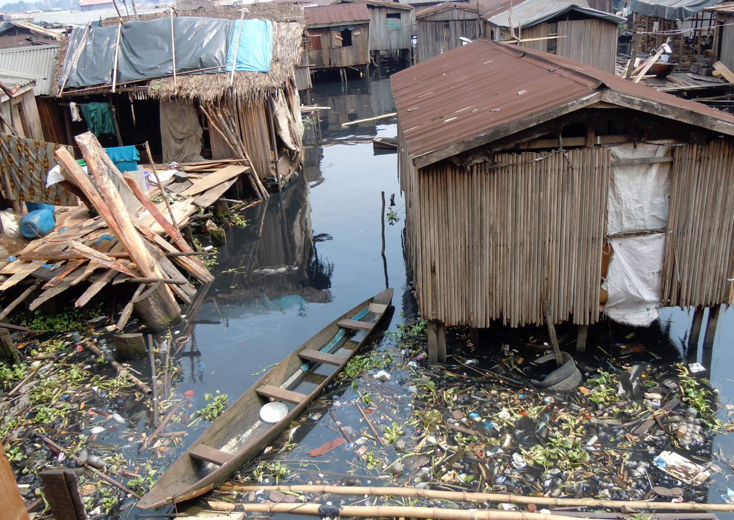

Urban Issues and Challenges - A major city in an LIC/NEE

Identify three challenges of living in squatter settlements in a major LIC or NEE city you have studied?

What are the disadvantages of the informal economy in a major LIC or NEE city you have studied?

Identify three challenges associated with the growth of a major LIC or NEE city you have studied?

How has the growth of a major LIC or NEE city you have studied caused inequality?

Identify three environmental issues cause by the growth of a major LIC or NEE city you have studied.

Give three ways urban planning helps the urban poor in a major LIC or NEE city you have studied?

What are the main challenges facing a major LIC or NEE city you have studied?

What has been done to reduce traffic congestion in a major LIC or NEE city you have studied?

Describe the location of a major LIC or NEE city you have studied.

What are the main causes of population growth in an LIC or NEE city you have studied.

Give three examples of the national importance of the major LIC / NEE city you have studied.

What opportunities are associated with the growth of a major LIC or NEE city you have studied?

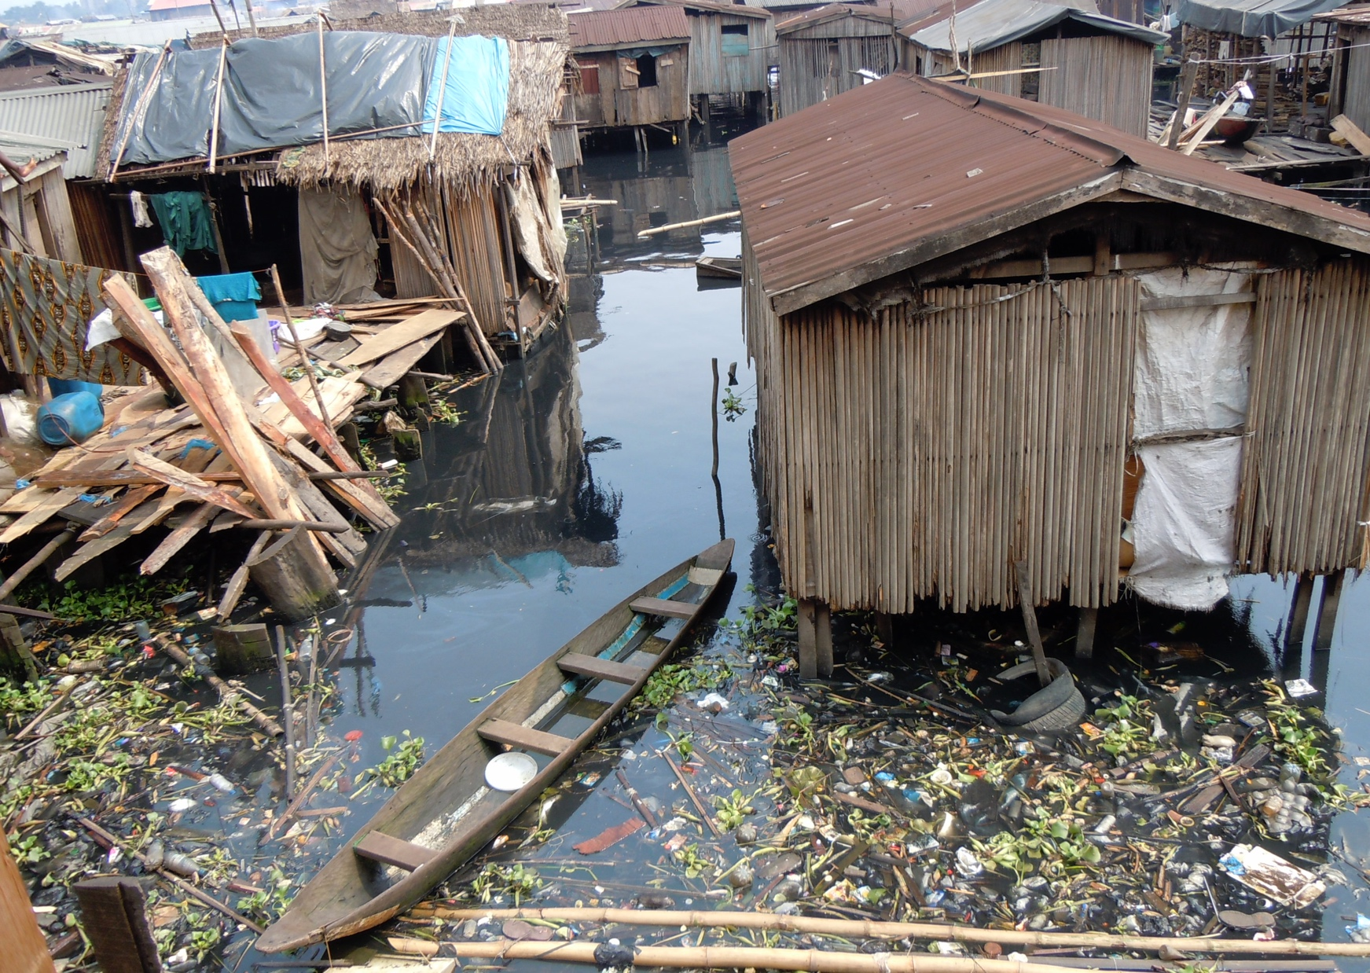

* Managing urban growth e.g. the growth of slums and squatter settlements
* Providing clean water, sanitation and energy
* Providing access to services such as health care and education
* Reducing unemployment and crime
* Managing environmental issues

Makoko is a squatter settlement combining 6 ‘villages’ across water and land. Challenges include:

* The homes are built from materials such as wood and metal sheets
* They do not have basic facilities or sanitation
* The lack of sanitation and refuse removal means the Lagos Lagoon is becoming heavily polluted.
* Fresh water has to be collected from stand-pipes
* Close proximity to industry leads to considerable pollution

The disadvantages of the informal economy include:

* Jobs are poorly paid
* They are unregulated
* They can often be dangerous
* Sick pay is not available
* People working in the informal economy do not pay tax and contribute to improvements in the infrastructure

**Example answers for this section cover Lagos, Nigeria.**

The Lagos Metropolitan Area Transport Authority (LAMATA) was set up by the Lagos state government in 2003 to improve transport in the city. The Authority set up a bus rapid transit (BRT) system that runs from north-south from the suburbs to the CBD on Lagos Island. The system provides a dedicated land for buses. Over 200,000 people use the system each day. A new light railway scheme is being developed in Lagos. The first stage of the Lagos Rail Mass Transit (LRMT) opened in 2016 and runs from a west-east route into the CBD. The system carries seven times as many passengers as the BRT.

* Waste disposal - authorities only collect 40% of the 10 000 tonnes of waste developed daily.
* Only 13% of waste is recycled
* Air pollution in Lagos is 500 times higher than the recommended limit
* Traffic congestion - Lagos is one of the most congested cities in the world leading to high levels of pollution and causes delays leading to businesses losing money

As the result of urbanisation the gap between rich and poor in Lagos has widened. For some, the booming economy of Lagos has led to great wealth. Yet, over 60% of the population of Lagos live in squatter settlements (slums), such as Makoko. Many of the houses of Makoko are built on stilts above Lagos Lagoon. Most of the residents of Makoko earn as little as $1.25 per day (approximately £1), working in the informal economy.

Lagos is Nigeria’s largest city. It lies in the south-west of the country on the coast of the Gulf of Guinea close to Nigeria’s border with Benin. The city was originally a small fishing village on an island until Portuguese settlers arrived in the 15th Century. In the early twentieth century it became the capital city of Nigeria until 1991 when the government moved to Abuja.

The main driver of growth in Lagos over the past 50 years has been rural– urban migration. People are encouraged to leave the countryside by push factors such as the lack of job opportunities and low wages (Figure 14.6). They are brought to the city by pull factors such as the prospect of well-paid work and the attraction of an urban lifestyle.

Another reason for Lagos’ population growth is the high rate of natural increase in the city’s population. This is due to the city’s youthful population, since most migrants to the city are young.

Urban Issues and Challenges - A major city in an LIC/NEE

Examples of the national importance of Lagos:

* Lagos is home to most banks, financial institutions and the stock exchange
* 80% of Nigeria’s industry is located in Lagos
* The city produces 25% of Nigeria’s GDP
* Most major companies and TNCs have their headquarters in Lagos
* 80% of Nigeria’s imports come through its docks, with 70% of exports passing through too
* Lagos is home to many national media organisations including newspapers and TV stations
* Lagos is home to the country’s film industry

**Access to services:**

* Healthcare is better in the city than the countryside with more hospitals, doctors and clinics
* State schools offer schooling for all children

**Improved economic development:**

* Lagos is dominated by the manufacturing industry providing many jobs and opportunities for people
* The growth of commercial and industrial zones has led to economic development
* Economic development provides funding for improving transport infrastructure, electric supply and sanitation

**Access to resources:**

* A reasonably reliable water supply is provided
* New water treatment plants are being developed
* Lagos provides a more reliable supply of energy

Improving safety

* Police and military patrols provide safety
* Increasing street lighting to make people feel safer at night

Settlement upgrading

* A 7 year upgrading programme for squatter settlements
* 1 million people have benefited from upgraded roads, the construction of new schools and health centres as well as introducing sanitation and bore holes for fresh water
* Local people were involved, improving their skills

Other policies

* The floating Maloko school was created to provide education for local children
* A water master plan has been introduced
* The introduction of an energy plan to provide reliable energy supplies across the city

Lagos faces a considerable number of challenges in the future. These include:

• Population growth – By 2035 the population is predicted to reach 40 million. If this is the case it will be one of the world’s top three megacities;

• Population density – Lagos is already four times more crowded than London. There is a finite amount of space for its population;

• Rising sea level – By the end of the twenty-first century, the sea is expected to rise by around one metre. This is a threat to low-lying Lagos;

• Water supply – Although Lagos receives tropical levels of rainfall, 2000mm per year, the city lacks the infrastructure to deliver safe, clean and affordable water to its population;

• Power supply – The supply of electricity in Lagos is very unreliable. While wealthy residents have their own generators, the poor have to use other forms of energy.