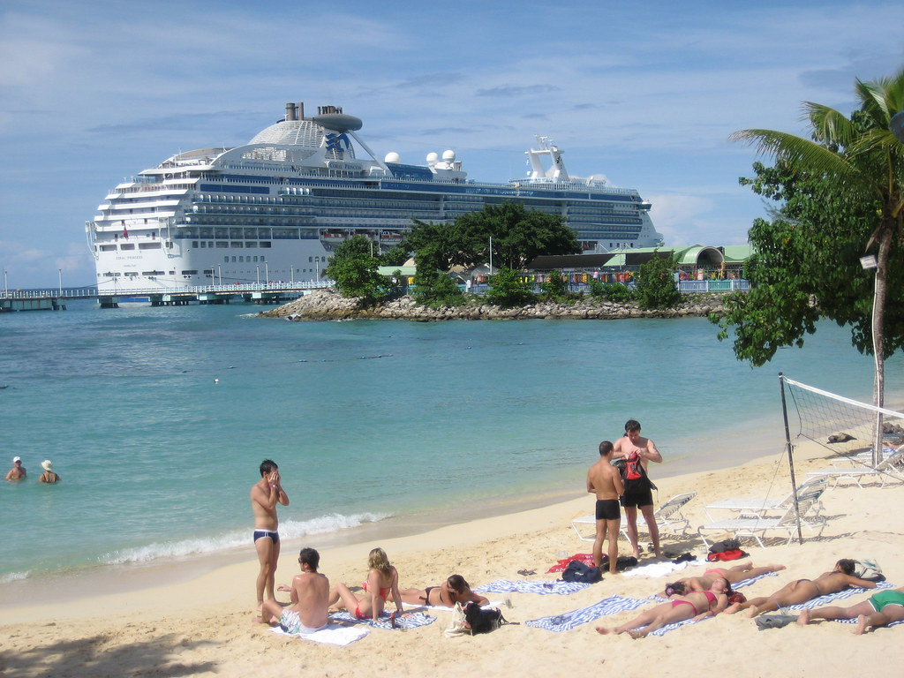

Changing Economic World - Reducing the development gap

What is aid and how can it help the development gap?

How can industrial development reduce the development gap?

How can micro-finance loans reduce the development gap?

How can investment reduce the development gap?

Identify three strategies for reducing the development gap.

Identify the positive impacts of the growth of tourism in your case study area.

How can Fairtrade reduce the development gap?

Briefly describe the growth in tourism in your case study location

How can debt relief reduce the development gap?

Identify the negative impacts of the growth of tourism in your case study area.

Identify a case study of how the growth of tourism in an LIC or NEE helps to reduce the development gap.

What is the development gap?



Changing Economic World - Reducing the development gap

Changing Economic World - Reducing the development gap

Micro-finance loans offer financial support to community groups or individuals to start a small business. If businesses are successful, they will create jobs and increase people’s income.

Industrial development brings employment opportunities in construction, manufacturing and service industries. Increased individual wealth leads to improvements in health, education and service provision through the payment of more taxes.

Countries, organisations (e.g. the World Bank) and transnational corporations (TNCs) invest in low-income countries (LICs) to increase profits. Investments lead to improvements in:

* infrastructure (e.g. road networks and airports)
* services (water, sanitation and electricity)
* dams and reservoirs (for hydro-electric power)
* industrial developments

Aid is usually in the form of financial assistance offered by countries, organisations and TNCs. Long term aid supports development projects such as improving sanitation, water supply and education. Short term aid is often given in response to natural disasters.

Investment, industrial development and tourism, aid, intermediate technology, Fairtrade, Debt relief and micro-finance loans.

In the 1970s and 1980s, many countries borrowed a significant amount of money for large scale development projects. Some of these countries have fallen into considerable debt repaying loans or high rates of interest. Debt relief involves cancelling money owed, allowing more significant investment in development projects such as road building and health care.

Case studies will vary depending on what you have studied in class. However, an example for Jamaica is included below.

* Tourism contributes over 50% of the country’s total foreign exchange earnings (approx. US$2b)
* Tourism employs the second largest number of Jamaicans (approximately 200,000)
* Local farmers benefit by supplying hotels
* The infrastructure has improved as the result of tourism

Fairtrade involves paying farmers a fair price for their products and investing in local communities. Fair-trade also promotes fair wages for farmers and their workforce.

The development gap is the difference in levels of development between the richest and poorest countries in the world. Some believe that the development gap between high income countries (HICs) and low-income countries (LICs) is increasing.

Case studies will vary depending on what you have studied in class. However, an example for Jamaica is included below.

* Despite the benefits of tourism, pockets of poverty still exist in Jamaica
* The development of infrastructure, such as roads, has come much later as authorities prioritised port and airport investment.

Case studies will vary depending on what you have studied in class. However, examples could include:

* Jamaica
* Tunisia
* The Maldives

Case studies will vary depending on what you have studied in class. However, an example for Jamaica is included below.

There has been an almost exponential growth in the number of visitor arrivals to Jamaica between 1994 and 2016. Although visitor arrivals continued to increase in 2009 the growth was not in line with previous years due to the recession which reduced disposable income.

Total visitor expenditure increased from US$128,706,000 in 1975 to US$2,608,798,000 in 2016.