**Glacial Landscapes in the UK**

**Multiple choice knowledge checker**

**Introduction to glacial environments, erosion and weathering**

|  |  |  |
| --- | --- | --- |
| 1. | **What is name given to the period when the UK last experienced a glacial period?** | |
| ⭘ | A. | Late Devonian |
| ⭘ | B. | Late Devensian |
| ⭘ | C. | Late Donovan |

|  |  |  |
| --- | --- | --- |
| 2. | **True or false?**  **Some 25,000 years ago vast ice sheets spread over the UK from the north and northeast to cover all of northern Wales and northern England.** | |
| ⭘ | A. | True |
| ⭘ | B. | False |

|  |  |  |
| --- | --- | --- |
| 3. | **Which of the following is not an example of a glaciated upland area in the British Isles?** | |
| ⭘ | A. | Snowdonia |
| ⭘ | B. | The Lake District |
| ⭘ | C. | Cairngorms |
| ⭘ | D. | Dartmoor |

|  |  |  |
| --- | --- | --- |
| 4. | **What is the name of permanently frozen land found on the edge of ice sheets?** | |
| ⭘ | A. | Permahair |
| ⭘ | B. | Permaham |
| ⭘ | C. | Premafroze |
| ⭘ | D. | Permafrost |

|  |  |  |
| --- | --- | --- |
| 5. | **What is the name given to areas found on the edge of glacial environments?** | |
| ⭘ | A. | PeriPeriGlacial |
| ⭘ | B. | Periglacial |
| ⭘ | C. | Proglacial |
| ⭘ | D. | Permoglacial |

|  |  |  |
| --- | --- | --- |
| 6. | **True or false?**  **Glacial processes have been responsible for sculpting some of the UK's most dramatic landscapes.** | |
| ⭘ | A. | True |
| ⭘ | B. | False |

|  |  |  |
| --- | --- | --- |
| 7. | **Which of the following describes the process of glacial erosion known as plucking?** | |
| ⭘ | A. | When meltwater from a glacier freezes around lumps of cracked and broken rock. When the ice moves downhill, rock is pulled from the back wall. |
| ⭘ | B. | Rock that is frozen to the base and the back of the glacier scrapes the bedrock. This acts like sandpaper and erodes the bedrock. |

|  |  |  |
| --- | --- | --- |
| 8. | **Which of the following describes the process of glacial erosion known as abrasion?** | |
| ⭘ | A. | When meltwater from a glacier freezes around lumps of cracked and broken rock. When the ice moves downhill, rock is pulled from the back wall. |
| ⭘ | B. | Rock that is frozen to the base and the back of the glacier scrapes the bedrock. This acts like sandpaper and erodes the bedrock. |

|  |  |  |
| --- | --- | --- |
| 9. | **Identify the main type of weathering that occurs in glacial environments.** | |
| ⭘ | A. | Hydrolysis |
| ⭘ | B. | Freeze-thaw |
| ⭘ | C. | Carbonation |

|  |  |  |
| --- | --- | --- |
| 10. | **Which of the following conditions are required for freeze-thaw weathering to occur?** | |
| ⭘ | A. | Frequent temperature changes above and below freezing. |
| ⭘ | B. | Temperatures constantly below freezing. |
| ⭘ | C. | The presence of liquid water. |
| ⭘ | D. | The presence of rocks with cracks/holes. |

**Glacial Movement, Transportation and Deposition**

|  |  |  |
| --- | --- | --- |
| 11. | **What causes glaciers to move?** | |
| ⭘ | A. | Friction between the ice and bedrock. |
| ⭘ | B. | The weight of ice and friction with the bedrock. |
| ⭘ | C. | The weight of the ice and gravity. |

|  |  |  |
| --- | --- | --- |
| 12. | **What is basal slip?** | |
| ⭘ | A. | The weight of ice causing a glacier to move. |
| ⭘ | B. | The slipping and deformation of individual ice crystals within the glacier causing it to move. |
| ⭘ | C. | When meltwater beneath a glacier enables it to slide forward a few metres a year. |

|  |  |  |
| --- | --- | --- |
| 13. | **What is internal deformation?** | |
| ⭘ | A. | The weight of ice causing a glacier to move. |
| ⭘ | B. | The slipping and deformation of individual ice crystals within the glacier causing it to move. |
| ⭘ | C. | When meltwater beneath a glacier enables it to slide forward a few metres a year. |

|  |  |  |
| --- | --- | --- |
| 14. | **What occurs when the amount of additional and ice accumulation in a year exceeds the amount of melting (ablation)?** | |
| ⭘ | A. | Glacial retreat |
| ⭘ | B. | Glacial advance |
| ⭘ | C. | Glacial approach |

|  |  |  |
| --- | --- | --- |
| 15. | **What happens when the amount of ablation exceeds accumulation?** | |
| ⭘ | A. | Glacial retreat |
| ⭘ | B. | Glacial advance |
| ⭘ | C. | Glacial approach |

|  |  |  |
| --- | --- | --- |
| 16. | **What is the name of material transported by a glacier?** | |
| ⭘ | A. | Bedrock |
| ⭘ | B. | Moroon |
| ⭘ | C. | Moraine |

|  |  |  |
| --- | --- | --- |
| 17. | **What is the furthest advance of a glacier marked by?** | |
| ⭘ | A. | Lateral moraine |
| ⭘ | B. | Medial moraine |
| ⭘ | C. | Terminal moraine |

|  |  |  |
| --- | --- | --- |
| 18. | **What is the name of the process that causes smaller glaciers in mountainside depressions to move?** | |
| ⭘ | A. | Bulldozing |
| ⭘ | B. | Advancing slip |
| ⭘ | C. | Rotational slip |

|  |  |  |
| --- | --- | --- |
| 19. | **What is the name of sediment deposited by meltwater towards the snout of a glacier?** | |
| ⭘ | A. | Till |
| ⭘ | B. | Moraine |
| ⭘ | C. | Glacial trough |

|  |  |  |
| --- | --- | --- |
| 20. | **True or false?**  **Till is well sorted.** | |
| ⭘ | A. | True |
| ⭘ | B. | False |

|  |  |  |
| --- | --- | --- |
| 21. | **Identify the feature formed when meltwater pouring from the snout of a glacier transports then deposits material.** | |
| ⭘ | A. | Terminal moraine |
| ⭘ | B. | Outwash plain |
| ⭘ | C. | Roche moutonnée |

|  |  |  |
| --- | --- | --- |
| 22. | **True or false?**  **Sediment found on outwash plains is better sorted and more rounded.** | |
| ⭘ | A. | True |
| ⭘ | B. | False |

**Glacial Landforms of Erosion**

|  |  |  |
| --- | --- | --- |
| 23. | **What is the name of an arm-chair shaped glacial landform found on mountainsides?** | |
| ⭘ | A. | Arete |
| ⭘ | B. | Pyramidal peak |
| ⭘ | C. | Corrie |

|  |  |  |
| --- | --- | --- |
| 24. | **Identify the erosional process that is responsible for the steep back walls typically found in corries.** | |
| ⭘ | A. | Plucking |
| ⭘ | B. | Basal slip |
| ⭘ | C. | Abrasion |

|  |  |  |
| --- | --- | --- |
| 25. | **What is the name of a lake trapped within the bowl of a corrie?** | |
| ⭘ | A. | Ribbon lake |
| ⭘ | B. | Tarn |
| ⭘ | C. | River |

|  |  |  |
| --- | --- | --- |
| 26. | **Which of the following are processes of erosion and weathering involved in the formation of a corrie?** | |
| ⭘ | A. | Freeze-thaw |
| ⭘ | B. | Plucking |
| ⭘ | C. | Abrasion |
| ⭘ | D. | Rotational slip |

|  |  |  |
| --- | --- | --- |
| 27. | **Identify the narrow, steep-sided ridge formed when two or more carries erode back to back.** | |
| ⭘ | A. | Pyramidal peak |
| ⭘ | B. | Arête |
| ⭘ | C. | Truncated spur |

|  |  |  |
| --- | --- | --- |
| 28. | **Identify the pronounced peak formed when several carries erode back to back into a mountain.** | |
| ⭘ | A. | Arete |
| ⭘ | B. | Truncated spur |
| ⭘ | C. | Pyramidal peak |

|  |  |  |
| --- | --- | --- |
| 29. | **Which of the following is an example of a pyramidal peak?** | |
| ⭘ | A. | Blowderhorn |
| ⭘ | B. | Matterhorn |
| ⭘ | C. | Prezdahorn |

|  |  |  |
| --- | --- | --- |
| 30. | **What are u-shaped valleys also known as?** | |
| ⭘ | A. | V shaped valleys |
| ⭘ | B. | Ribbon lakes |
| ⭘ | C. | Glacial troughs |

|  |  |  |
| --- | --- | --- |
| 31. | **Identify the landform created when interlocking spurs are removed by glacial erosion.** | |
| ⭘ | A. | Trencated spurs |
| ⭘ | B. | Trunkated spurs |
| ⭘ | C. | Truncated spurs |

|  |  |  |
| --- | --- | --- |
| 32. | **Identify the landform created when smaller glaciers in tributary river valleys melt.** | |
| ⭘ | A. | U-shaped valley |
| ⭘ | B. | Hanging valley |
| ⭘ | C. | Truncated spurs |

|  |  |  |
| --- | --- | --- |
| 33. | **Identify the deep freshwater lakes found in glacial troughs.** | |
| ⭘ | A. | Tarn |
| ⭘ | B. | Corrie lake |
| ⭘ | C. | Ribbon lake |

|  |  |  |
| --- | --- | --- |
| 34. | **Which of the following explain the reasons for increased erosion in glacial troughs resulting in the formation of ribbon lakes?** | |
| ⭘ | A. | A weaker bank of rock that is more easily eroded crosses the valley. |
| ⭘ | B. | At a tributary where additional ice flows into the valley. |
| ⭘ | C. | Where the valley sides become narrower increasing the depth and power of the glacier. |
| ⭘ | D. | At a point where there is a rock lip. |

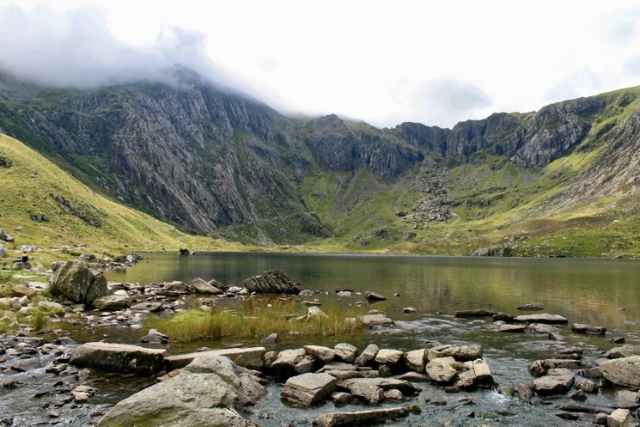

|  |  |  |
| --- | --- | --- |
| 35. | **Identify the glacial landform in the image above.** | |
| ⭘ | A. | U-shaped valley |
| ⭘ | B. | Corrie |
| ⭘ | C. | Hanging valley |

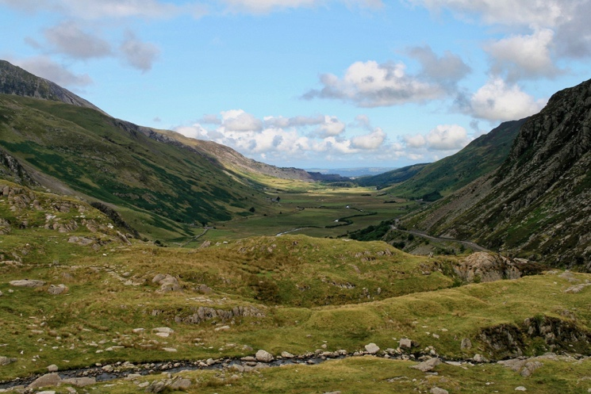

|  |  |  |
| --- | --- | --- |
| 36. | **Identify the glacial landform in the image above.** | |
| ⭘ | A. | Glacial trough |
| ⭘ | B. | Corrie |
| ⭘ | C. | Hanging valley |

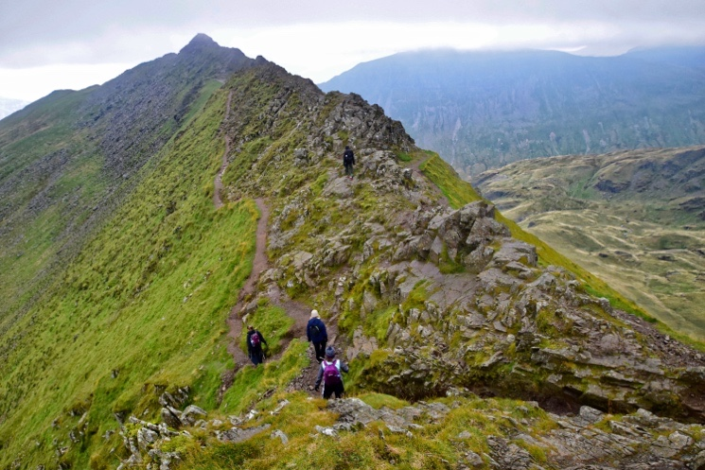

|  |  |  |
| --- | --- | --- |
| 37. | **Identify the glacial landform in the image above.** | |
| ⭘ | A. | Pyramidal peak |
| ⭘ | B. | Corrie |
| ⭘ | C. | Arête |

|  |  |  |
| --- | --- | --- |
| 38. | **Identify the landform labelled A.** | |
| ⭘ | A. | Ribbon lake |
| ⭘ | B. | Tarn |
| ⭘ | C. | Waterfall |

|  |  |  |
| --- | --- | --- |
| 39. | **Identify the landform labelled B.** | |
| ⭘ | A. | Arete |
| ⭘ | B. | Pyramidal Peak |
| ⭘ | C. | Truncated spur |

|  |  |  |
| --- | --- | --- |
| 40. | **Identify the landform labelled C.** | |
| ⭘ | A. | Arete |
| ⭘ | B. | Pyramidal Peak |
| ⭘ | C. | Truncated spur |

|  |  |  |
| --- | --- | --- |
| 41. | **Identify the landform labelled D.** | |
| ⭘ | A. | Corrie |
| ⭘ | B. | U shaped valley |
| ⭘ | C. | Hanging valley |

|  |  |  |
| --- | --- | --- |
| 42. | **Identify the landform labelled E.** | |
| ⭘ | A. | Arete |
| ⭘ | B. | Truncated spur |
| ⭘ | C. | Pyramidal peak |

|  |  |  |
| --- | --- | --- |
| 43. | **Identify the landform labelled F.** | |
| ⭘ | A. | Hanging valley |
| ⭘ | B. | Tarn |
| ⭘ | C. | Waterfall |

|  |  |  |
| --- | --- | --- |
| 44. | **Identify the landform labelled G.** | |
| ⭘ | A. | Hanging valley |
| ⭘ | B. | Tarn |
| ⭘ | C. | Waterfall |

|  |  |  |
| --- | --- | --- |
| 45. | **Identify the landform labelled H.** | |
| ⭘ | A. | V shaped valley |
| ⭘ | B. | Hanging valley |
| ⭘ | C. | U shaped valley |

|  |  |  |
| --- | --- | --- |
| 46. | **Identify the landform labelled I.** | |
| ⭘ | A. | Ribbon lake |
| ⭘ | B. | Tarn |
| ⭘ | C. | Waterfall |

**Glacial Landforms of Transportation and Deposition**

|  |  |  |
| --- | --- | --- |
| 47. | **True or false?**  **Moraines are formed by the deposition of poorly sorted, angular till deposits, carried by ice then dumped when it melts.** | |
| ⭘ | A. | True |
| ⭘ | B. | False |
| ⭘ | C. |  |
| ⭘ | D. |  |

|  |  |  |
| --- | --- | --- |
| 48. | **Identify the type of moraine found along the sides of a glacier.** | |
| ⭘ | A. | Medial |
| ⭘ | B. | Terminal |
| ⭘ | C. | Lateral |
| ⭘ | D. | Ground |

|  |  |  |
| --- | --- | --- |
| 49. | **Identify the type of moraine found where two tributary glaciers meet.** | |
| ⭘ | A. | Medial |
| ⭘ | B. | Terminal |
| ⭘ | C. | Lateral |
| ⭘ | D. | Ground |

|  |  |  |
| --- | --- | --- |
| 50. | **Identify the type of moraine found on the bedrock between the ice.** | |
| ⭘ | A. | Medial |
| ⭘ | B. | Terminal |
| ⭘ | C. | Lateral |
| ⭘ | D. | Ground |

|  |  |  |
| --- | --- | --- |
| 51. | **Identify the type of moraine found at the snout of a glacier.** | |
| ⭘ | A. | Medial |
| ⭘ | B. | Terminal |
| ⭘ | C. | Lateral |
| ⭘ | D. | Ground |

|  |  |  |
| --- | --- | --- |
| 52. | **Which of the following moraines is most likely to be left intact when ice melts?** | |
| ⭘ | A. | Medial |
| ⭘ | B. | Lateral |
| ⭘ | C. | Ground |
| ⭘ | D. | Terminal |

|  |  |  |
| --- | --- | --- |
| 53. | **What is the name of a rock transported by ice and deposited in an area of different geology?** | |
| ⭘ | A. | Moraine |
| ⭘ | B. | Drumlin |
| ⭘ | C. | Erratic |

|  |  |  |
| --- | --- | --- |
| 54. | **True or false?**  **By pinpointing the source of an erratic scientists can identify the direction of movement of past ice sheets.** | |
| ⭘ | A. | True |
| ⭘ | B. | False |

|  |  |  |
| --- | --- | --- |
| 55. | **What are egg-shaped hills of deposited material, that often occur in groups, known as?** | |
| ⭘ | A. | Erratics |
| ⭘ | B. | Drumlins |
| ⭘ | C. | Moraines |

|  |  |  |
| --- | --- | --- |
| 56. | **What are drumlins formed from?** | |
| ⭘ | A. | Moraine |
| ⭘ | B. | Till |
| ⭘ | C. | Erratics |

|  |  |  |
| --- | --- | --- |
| 57. | **Drumlins indicate the past direction of ice movement. Which of the following is correct?** | |
| ⭘ | A. | The tapered end points in the direction of ice movement. |
| ⭘ | B. | The blunt end points in the direction of ice movement. |

|  |  |  |
| --- | --- | --- |
| 58. | **What is a group of drumlins known as?** | |
| ⭘ | A. | Swarm |
| ⭘ | B. | Group |
| ⭘ | C. | Pride |

**Land use in glaciated upland areas**

|  |  |  |
| --- | --- | --- |
| 59. | **Which of the following economic activities are carried out in glaciated upland areas?** | |
| ⭘ | A. | Pastoral farming |
| ⭘ | B. | Tourism |
| ⭘ | C. | Forestry |
| ⭘ | D. | Quarrying |
| ⭘ | E. | Growing arable crops such as wheat and barley. |

|  |  |  |
| --- | --- | --- |
| 60. | **Why are opportunities for agriculture limited in upland glaciated areas?** | |
| ⭘ | A. | Soils are thin and infertile. |
| ⭘ | B. | Population density is often high. |
| ⭘ | C. | Slopes are steep and often covered in scree. |
| ⭘ | D. | The climate is harsh, with high rainfall, low temperatures and strong winds. |

|  |  |  |
| --- | --- | --- |
| 61. | **Which of the following is the most common crop grown in glaciated upland areas?** | |
| ⭘ | A. | Barley |
| ⭘ | B. | Grass |
| ⭘ | C. | Wheat |
| ⭘ | D. | Rape seed |

|  |  |  |
| --- | --- | --- |
| 62. | **Which type of tree is most commonly used in commercial forestry in glaciated upland areas?** | |
| ⭘ | A. | Deciduous |
| ⭘ | B. | Coniferous |

|  |  |  |
| --- | --- | --- |
| 63. | **True or false?**  **Coniferous trees are fast-growing and well suited to the harsh climate and thin, acidic soils common in glaciated upland areas.** | |
| ⭘ | A. | True |
| ⭘ | B. | False |

|  |  |  |
| --- | --- | --- |
| 64. | **Which of the following rock is not typically quarried in glaciated upland areas?** | |
| ⭘ | A. | Slate |
| ⭘ | B. | Limestone |
| ⭘ | C. | Granite |
| ⭘ | D. | Chalk |

|  |  |  |
| --- | --- | --- |
| 65. | **True or false?**  **Tourism is a hugely important economic activity in upland glaciated areas.** | |
| ⭘ | A. | True |
| ⭘ | B. | False |

|  |  |  |
| --- | --- | --- |
| 66. | **Which of the following are popular leisure activities in glaciated upland areas?** | |
| ⭘ | A. | Zip lining |
| ⭘ | B. | Hiking |
| ⭘ | C. | Cycling |
| ⭘ | D. | Climbing |
| ⭘ | E. | Yachting |

**Conflicts in upland glaciated environments**

|  |  |  |
| --- | --- | --- |
| 67. | **True or false?**  **The variety of different land uses inevitably causes disagreements. Most of this conflict results from the mass influx of tourists to the region, especially during the summer months.** | |
| ⭘ | A. | True |
| ⭘ | B. | False |

|  |  |  |
| --- | --- | --- |
| 68. | **Which of the following is most likely to experience conflict with farming in glaciated upland areas?** | |
| ⭘ | A. | Quarrying |
| ⭘ | B. | Conservation |
| ⭘ | C. | Tourism |

|  |  |  |
| --- | --- | --- |
| 69. | **Which of the following is most likely to experience conflict with quarrying in glaciated upland areas?** | |
| ⭘ | A. | Farming |
| ⭘ | B. | Tourism |
| ⭘ | C. | Conservation |

|  |  |  |
| --- | --- | --- |
| 70. | **Which of the following is most likely to experience conflict with tourism in glaciated upland areas?** | |
| ⭘ | A. | Quarrying |
| ⭘ | B. | Conservation |
| ⭘ | C. | Farming |

|  |  |  |
| --- | --- | --- |
| 71. | **Which of the following are impacts of energy development in glaciated upland areas?** | |
| ⭘ | A. | The landscape becomes scarred. |
| ⭘ | B. | Local businesses benefit from green energy. |
| ⭘ | C. | Wind turbines support wildlife including birds. |

|  |  |  |
| --- | --- | --- |
| 72. | **Which of the following are impacts of reservoir construction in glaciated upland areas?** | |
| ⭘ | A. | Destruction of habitats. |
| ⭘ | B. | Creation of tourist amenities. |
| ⭘ | C. | Flooding will no longer occur in the river beyond the dam. |

|  |  |  |
| --- | --- | --- |
| 73. | **Which of the following are impacts of forestry in glaciated upland areas?** | |
| ⭘ | A. | Biodiversity decreases |
| ⭘ | B. | Employment opportunities for local people. |
| ⭘ | C. | Biodiversity increases |

|  |  |  |
| --- | --- | --- |
| 74. | **True or false?**  **Conflicts can exist between economic development and conservation in glaciated upland areas.** | |
| ⭘ | A. | True |
| ⭘ | B. | False |

**Answers**

1. B
2. A
3. D
4. D
5. B
6. A
7. A
8. B
9. B
10. A, B and D
11. C
12. C
13. B
14. B
15. A
16. C
17. C
18. C
19. A
20. B
21. C
22. A
23. C
24. A
25. B
26. A, B and C
27. B
28. B
29. B
30. C
31. C
32. B
33. C
34. B and C
35. B
36. A
37. C
38. B
39. B
40. A
41. A
42. B
43. A
44. C
45. C
46. A
47. A
48. C
49. A
50. D
51. B
52. B
53. C
54. A
55. B
56. B
57. A
58. A
59. A, B, C and D
60. A, C and D
61. B
62. B
63. A
64. D
65. A
66. A, B, C and D
67. A
68. C
69. C
70. B
71. A and B
72. A and B
73. A and B
74. A