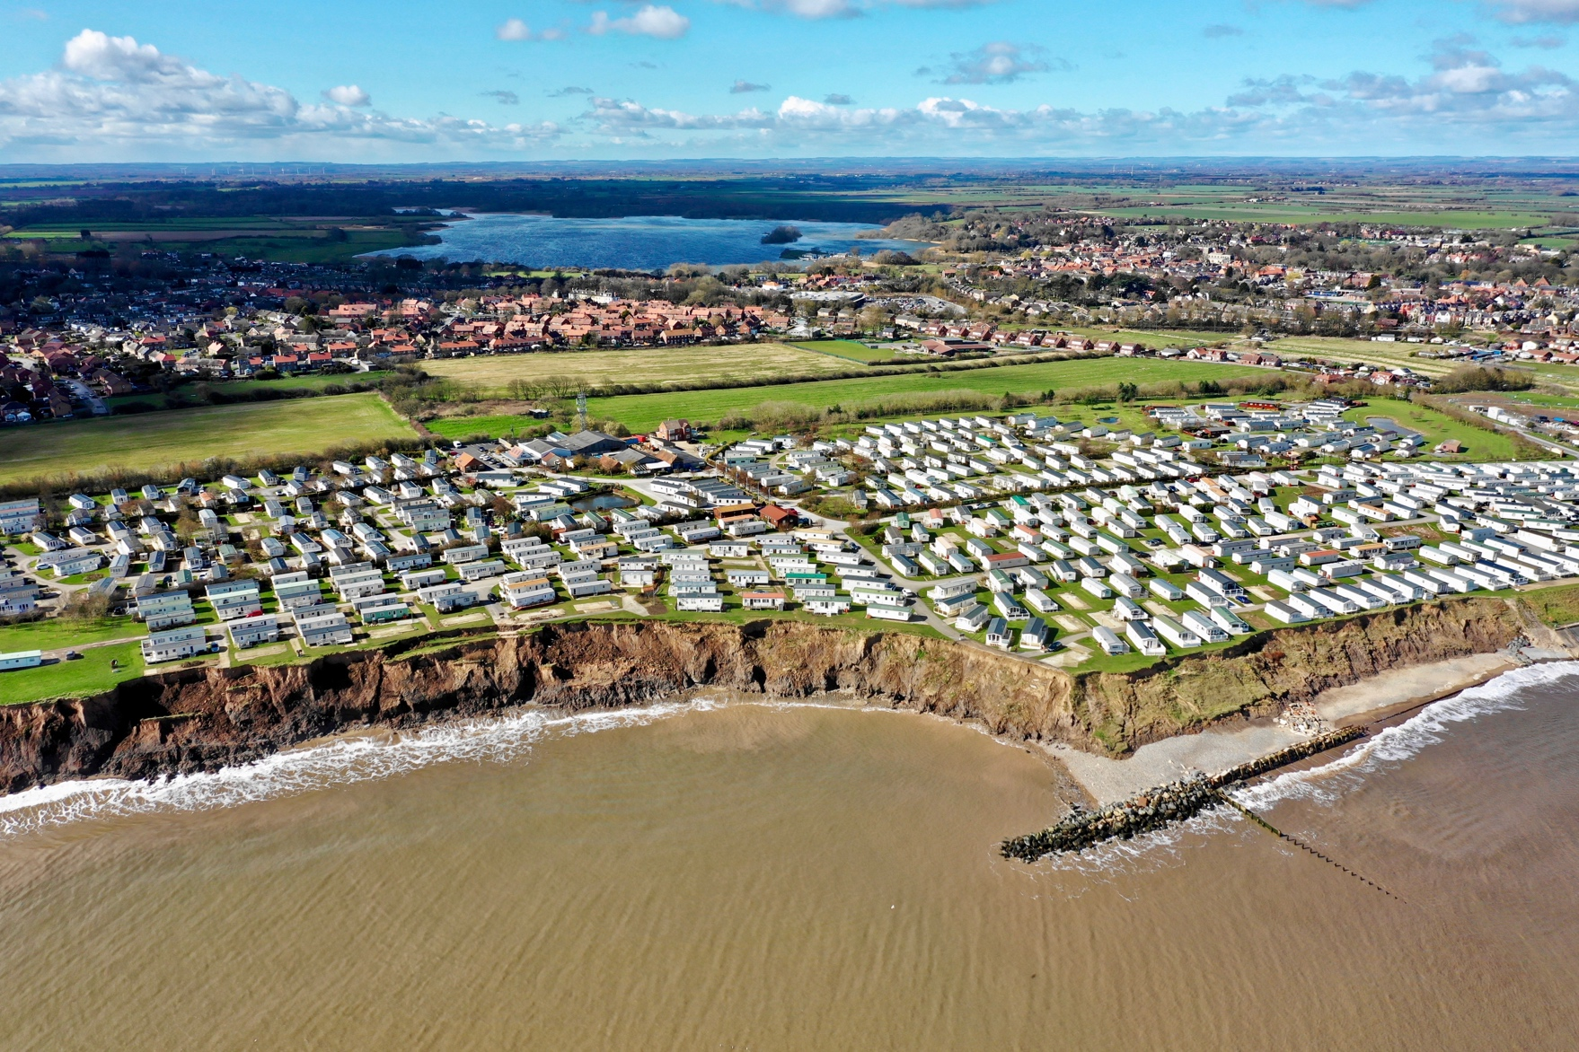

Explain the formation of a spit.

What is the difference between hard and soft engineering?

What are the social, economic and environmental benefits of a sea wall?

Study the image above showing coastal defences to the south of Hornsea. How do these sea defences help protect the coastline?

Identify 4 processes of mass movement.

Explain the formation of a wave-cut platform.

Explain the formation of a stack.

What is longshore drift?

Identify the two types of wave.

Identify 4 processes of coastal transportation.

What factors affect the size of waves?

Coastal environments

Identify 5 processes of coastal erosion.



Advantages - Social = give people a sense of safety and have promenades used by tourists. Economic = long life-span and excellent defence against high energy waves. Environmental = do not impede the movement of sediment along the coast.

Rock armour (large boulders) are piled up on the beach. They absorb the energy of waves and allow the build-up of a beach. Groynes trap sediment transported by longshore drift building up a wide sandy beach that protects the cliffs from erosion.

 Longshore drift moves material along a coastline. Where the coastline changes direction or the power of the waves is reduced (e.g. it meets a river) material is deposited. The sediment deposited builds up over time to form a spit.

Waves erode attack a weakness (crack) in a headland. Hydraulic action, abrasion and corrosion enlarge the crack forming a cave. Continued erosion causes an arch to form. This collapses due to weathering and gravity to leave a sea stack.

The sea attacks a weakness in the base of the cliff forming a wave cut notch by erosional processes such as hydraulic action, corrosion and abrasion. The cliff above collapses due to gravity. The cliff retreats. The remains of the cliff form a wave-cut platform.

Rockfall, landslide, mud slide and slumping.

Longshore drift is the zig-zag movement of material along the coast by the sea.

Coastal environments

Constructive and destructive waves.

Traction, saltation, suspension and solution.

The size of a wave is affected by:

* Its fetch (distance travelled)
* The speed of the wind blowing over the sea/ocean
* Wind duration (the longer the wind blows over the sea/ocean the larger the wave)

Corrasion, abrasion, attrition, hydraulic action and solution.

Hard engineering coastal management involves building artificial structures which try to control natural processes whereas soft engineering involves taking a more sustainable and natural approach to managing the coast.