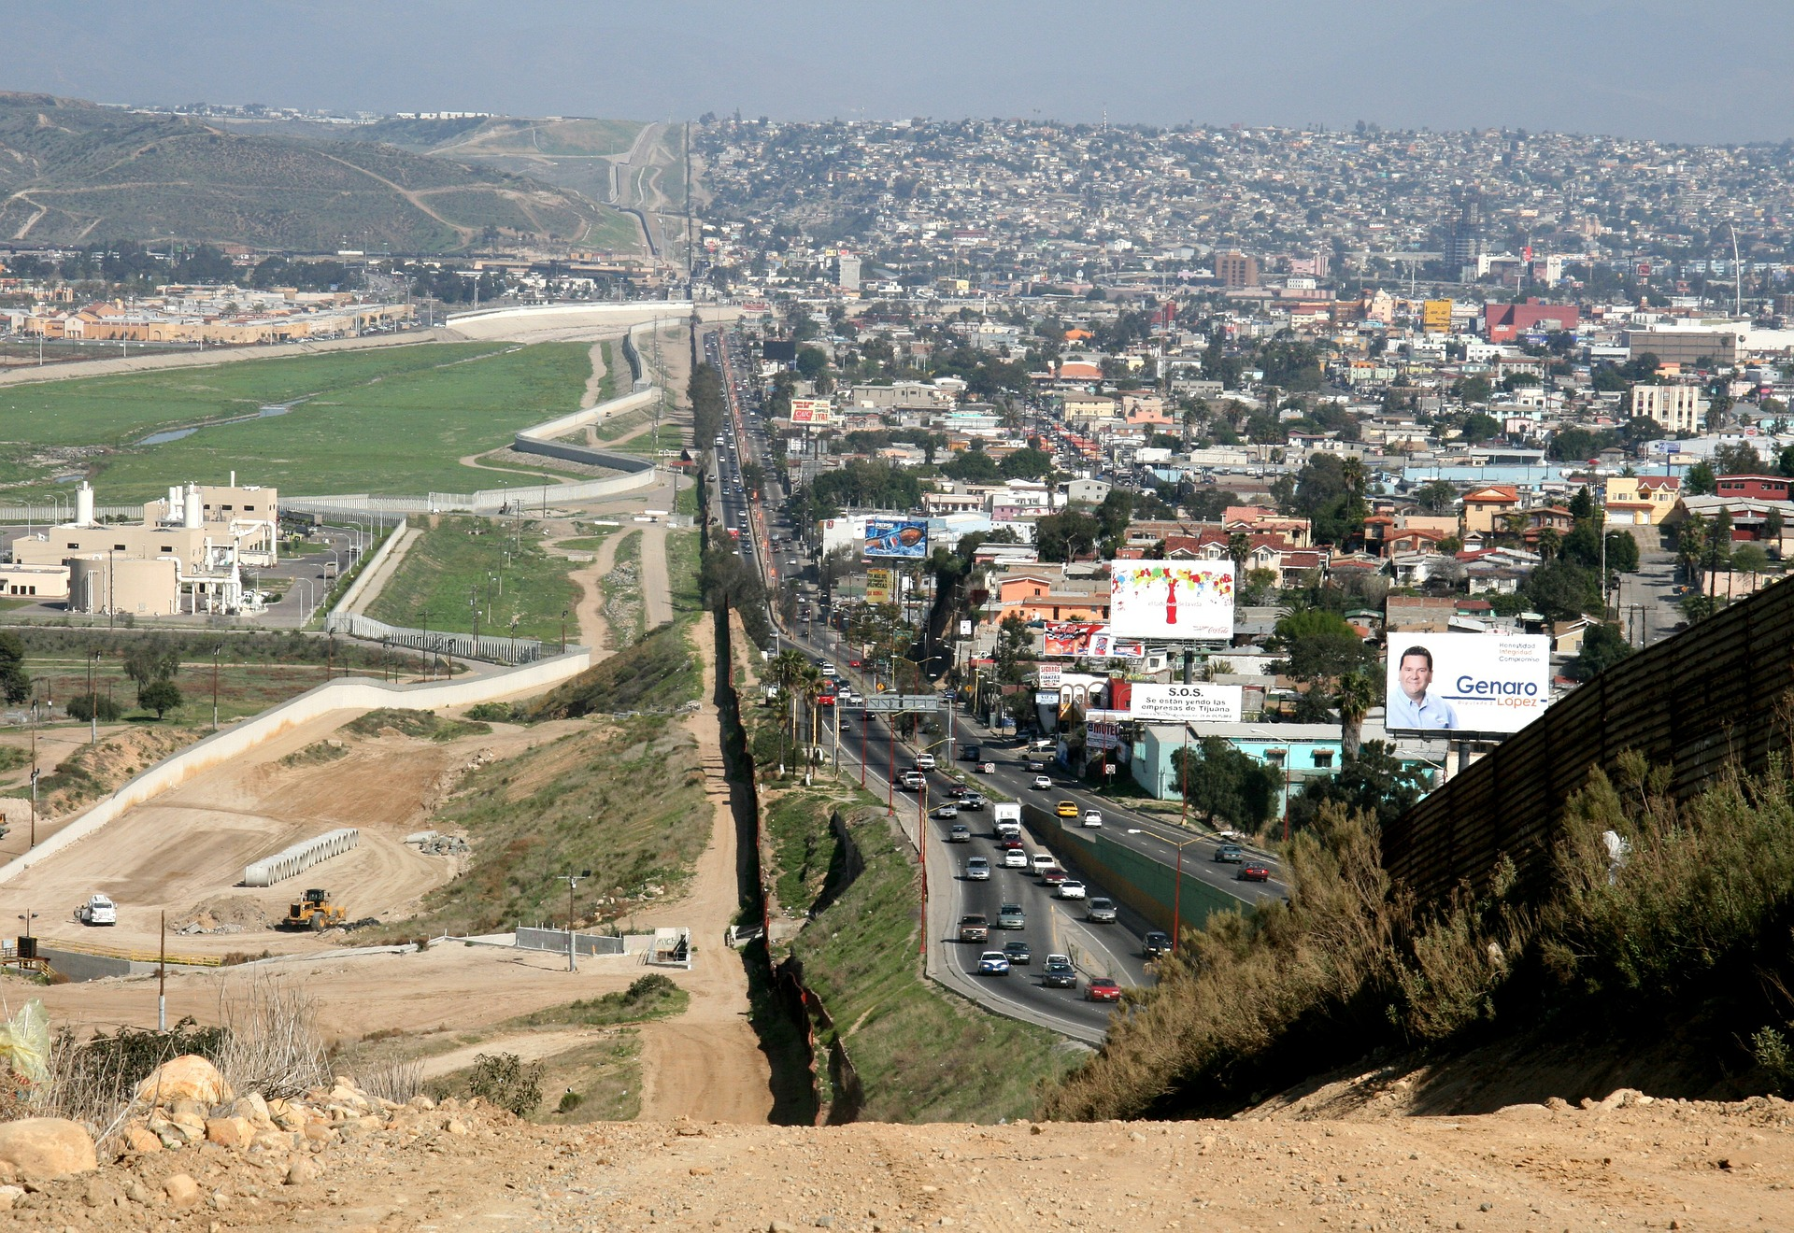

What is the demographic transition model?

Explain why population growth is the greatest in stage 2.

Draw a simple diagram to show the main features of the demographic transition model.

Why is the Human Development Index one of the most used measures of development?

Identify the three ways the World Bank classifies countries according to economic and social development.

Identify two consequences of uneven development.

Identify 4 social and economic measures of development.

Identify one economic and historical cause of uneven development.

Why is birth rate a better indicator of development than death rate?

Explain why relying on the export of commodities (raw materials) hinders economic development.

Give 3 physical causes of uneven development.

Define development.

Changing Economic World - Economic Development

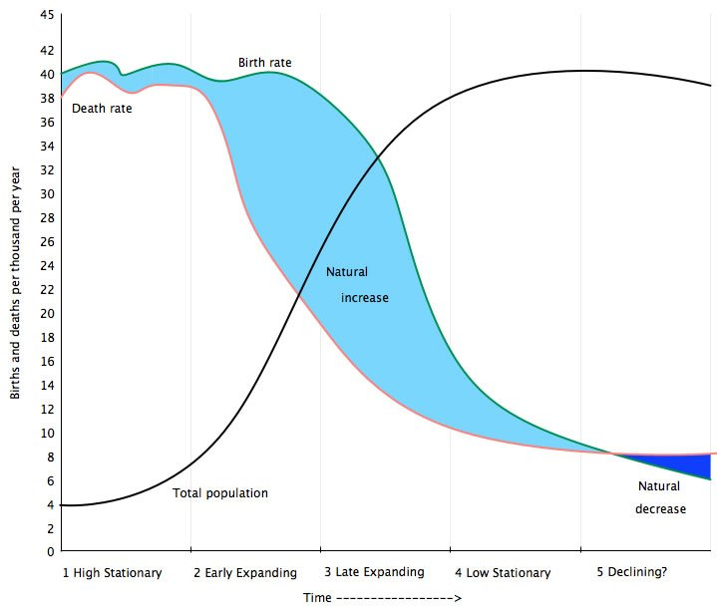

Changing Economic World - Economic Development

A high natural increase happens in stage 2 because the death rate falls rapidly due to improvements in healthcare and sanitation, whereas the birth rate remains high.

The Demographic Transition Model is a graph that shows changes in birth and death rates over time and how population changes as the result. It does not show the impact of migration on the total population.

The HDI incorporates a range of economic and social indicators of development including income, life expectancy and education to calculate an index from 0-1.

HIC - High income countries

NEE - Newly emerging economies

LIC - Low income countries

Death rates are a poor indicator of development because they can be high in LICs due to due to poverty, but also high in HICs where there may be an ageing population and many elderly people die of old age. However, high birth rates are typically associated with LICs where large families support a good income and infant mortality is high. However, birth rates in MICs are low due to the expense associated with having children.

* Disparities in wealth
* Disparities in health
* International migration

GNI, birth rate, death rate, infant mortality, life expectancy, people per doctor, literacy rates, access to safe water and the Human Development Index (HDI).

The progress of a country as it becomes economically and technologically advanced. It can also be applied to improvements in people’s quality of life such as increased incomes, human rights, healthy living conditions and educational opportunities.

LICs typically trade commodities whereas HICs tend to trade processed goods. Commodities are of lower value than processed goods. The price of commodities fluctuate causing great uncertainty and instability as countries try to develop. The imbalance in trade between HICs and LICs has increased the development gap.

**Weather and climate** - extreme conditions make economic development very challenging.

**Relief** - Mountainous regions are usually remote, with a poor infrastructure.

**Landlocked countries** - without a coastline, landlocked countries lack the benefits of sea trade.

**Tropical environments** - these environments are prone to pests and disease.

**Water shortages** - water is essential for life and development, therefore development is challenging where there is water scarcity.

Economic:

* poverty - a lack fo money slows development.
* trade - LICs have typically traded low value commodities not high value processed goods.

Historical:

Many colonial countries were exploited for their raw materials and over 10 million people were transported from Africa to North America to work as slaves. Since independence many colonial countries have experienced power struggles and civil wars. They also face challenges such as poor infrastructure and political instability.