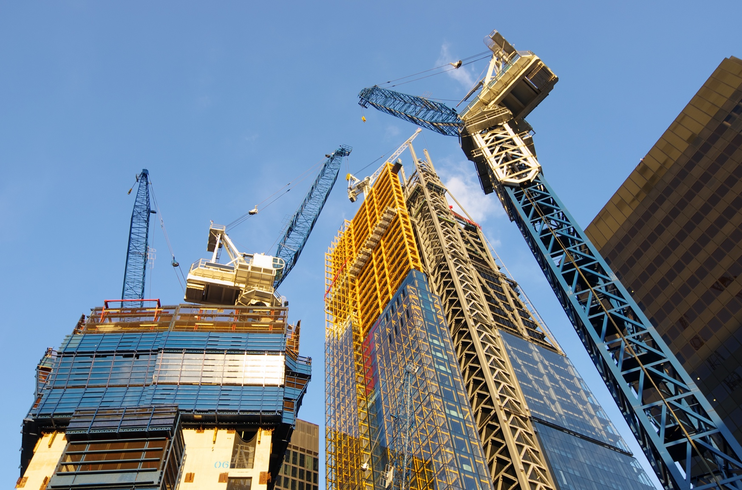

Urban Issues and Challenges - A major city in the UK

Give two positive impacts of urban sprawl on the rural-urban fringe of a city you have studied.

Give three examples of sustainable urban living.

Outline a social, economic and environmental challenge resulting from urban growth in a major city in the UK.

Outline three economic opportunities resulting from urban change in a major city in the UK.

Outline three social opportunities resulting from urban change in a major city in the UK.

Describe the negative effects of international migration on a major city in the UK.

Describe the UK’s population distribution.

Give two negative impacts of urban sprawl on the rural-urban fringe of a city you have studied.

Define urban regeneration and give an example within a city in a UK.

Identify two reasons for the international importance of a major city in the UK.

Describe the location of a major city in the UK.

Describe the positive effects of international migration on a major city in the UK.

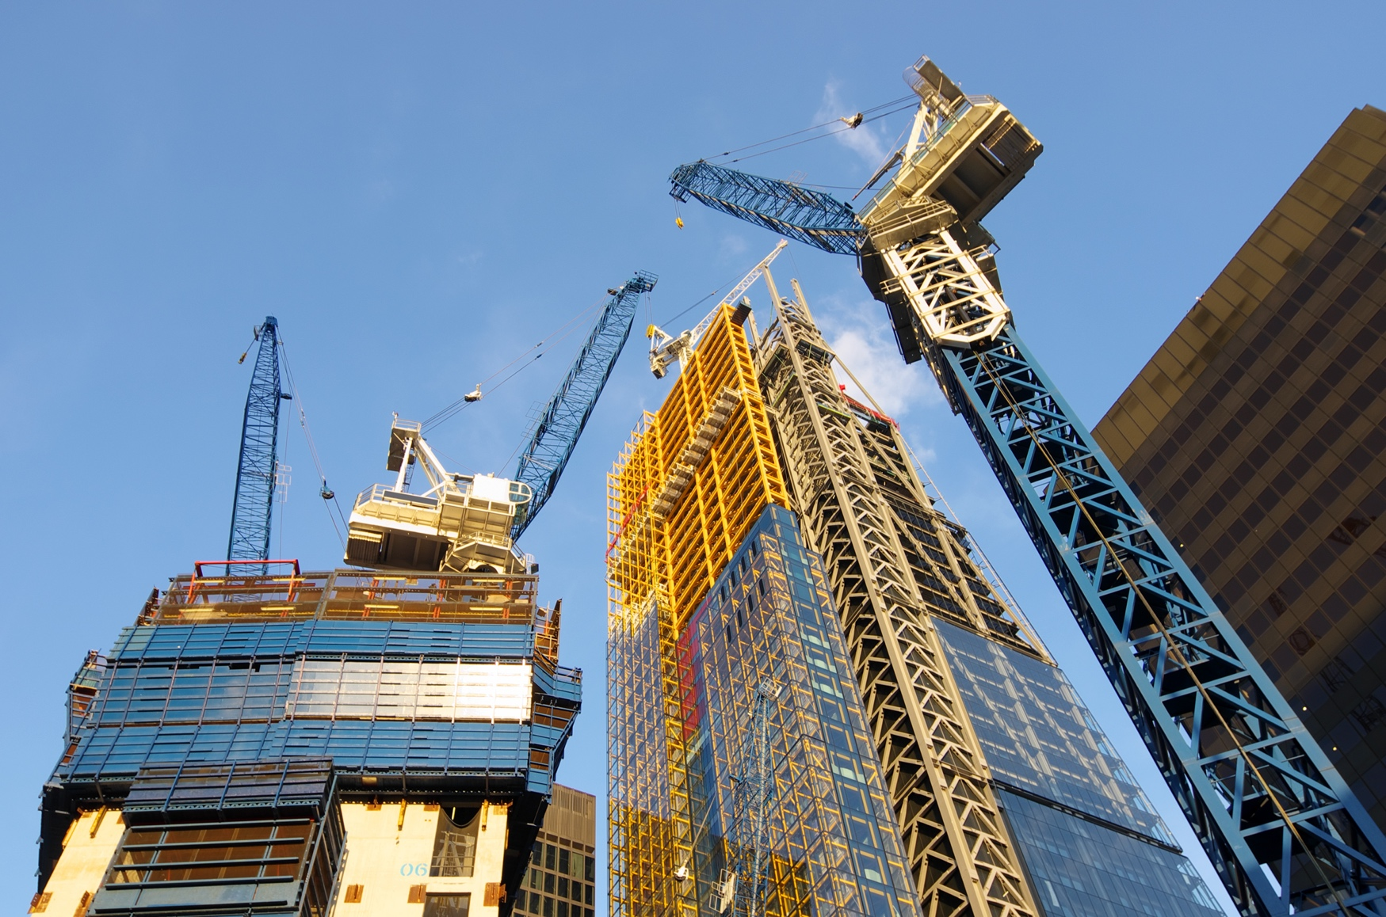

Urban Issues and Challenges - A major city in the UK

* London generates 22% of the UK’s GDP
* Housing in London’s top 10 boroughs are worth more than those in Northern Ireland, Scotland and Wales combined
* Over 200,000 start-up companies were established in 2015
* London’s transport network and connections allow the free-flow of goods and services
* London attracts educated graduates from around to work to take up jobs in research and development, finance and education who pay taxes to the UK government

**Economic**

* Urban deprivation is high with 27% of the population living in poverty (compared to 20% for the rest of England)
* Deprivation is increasing gin the outer boroughs as affordable housing in inner London is getting harder to find

**Social**

* London’s unemployment rate is is still higher than the UK average
* There are inconsistencies in the quality of healthcare
* The city is struggling to provide enough school places
* Rising housing costs are reducing living standards

**Environmental**

* Recycling rates are lower than anywhere else in the country
* Many buildings in East London have become derelict due to de-industrialisation
* Development of brownfield sites is expensive
* London has a huge range of recreational opportunities including shopping areas, theatres and restaurants
* London regularly hosts world-class sporting events
* Entertainment options have created many jobs for people
* London is well connected with an integrated transport systems including the underground buses, Tramlink and Docklands Light Railway
* Population growth has led to housing shortages, which local authorities and the government is struggling to address
* There are social and racial tension between some migrants and locals
* Increased pressure is being put on London’s schools with a shortage of places in some areas
* Increased competition for jobs which

London is located in South East England on the River Thames.

* Migration has added to the number of skilled workers competing for jobs which benefits companies looking to recruit
* Migrants contributed £20 billion to the UK’s public finances between 2000 and 2011
* London is one of the most culturally diverse cities in the UK. Migrants have brought different types of entertainment, clothing and foods

Examples of sustainable urban living strategies include:

* Creating green space
* Waste recycling
* Conserving energy and water
* Urban transport strategies

Upland areas, such as northern Scotland, tend to be sparsely populated because they are difficult to build on and the climate is often cold and wet. Also, these areas are difficult to farm and lack natural resources.

Some coastal locations have a high population density. This is particularly the case close to estuaries because harbours can be constructed. In the past, this enabled the fishing industry to develop along with ports being established to enable trading to occur.

Urban areas have also developed where there are large reserves of natural resources. This includes iron ore and coal e.g. Newcastle and Leeds.

Population density is high in the south-east of England, due to the favourable climate and proximity to the capital city of the UK, London. The city has many industries and is a global financial centre.

London is a modern-day world city. The reasons for this include:

* With New York it is one of the two most important financial centres in the world
* It is the headquarters of many large, international companies
* It is an international centre for media and communications networks
* It is an international centre for education, including well-renowned universities
* It is an international centre for legal and medical facilities
* It is an international centre for entertainment and tourism

Urban regeneration involves the investment of capital in the revival of old, urban areas by either improving what is there or clearing it away and rebuilding.

Examples in London include the Lower Lea Valley Redevelopment project (Olympic Park) and London’s Docklands.

**Example answers for this section cover London**

* House prices can increase for those already living in the rural-urban fringe
* Increase in services to meet the needs of the growing population such as schools and healthcare
* Cultural diversity could increase
* The transport infrastructure could be improved to meet the needs of the growing population
* Public transport is worse in rural areas, so there are more cars on the road.
* Increase in urban sprawl
* Land is unlikely to return to countryside once it is built on
* Valuable farmland or land used for recreation can be lost
* Natural habitats may be destroyed