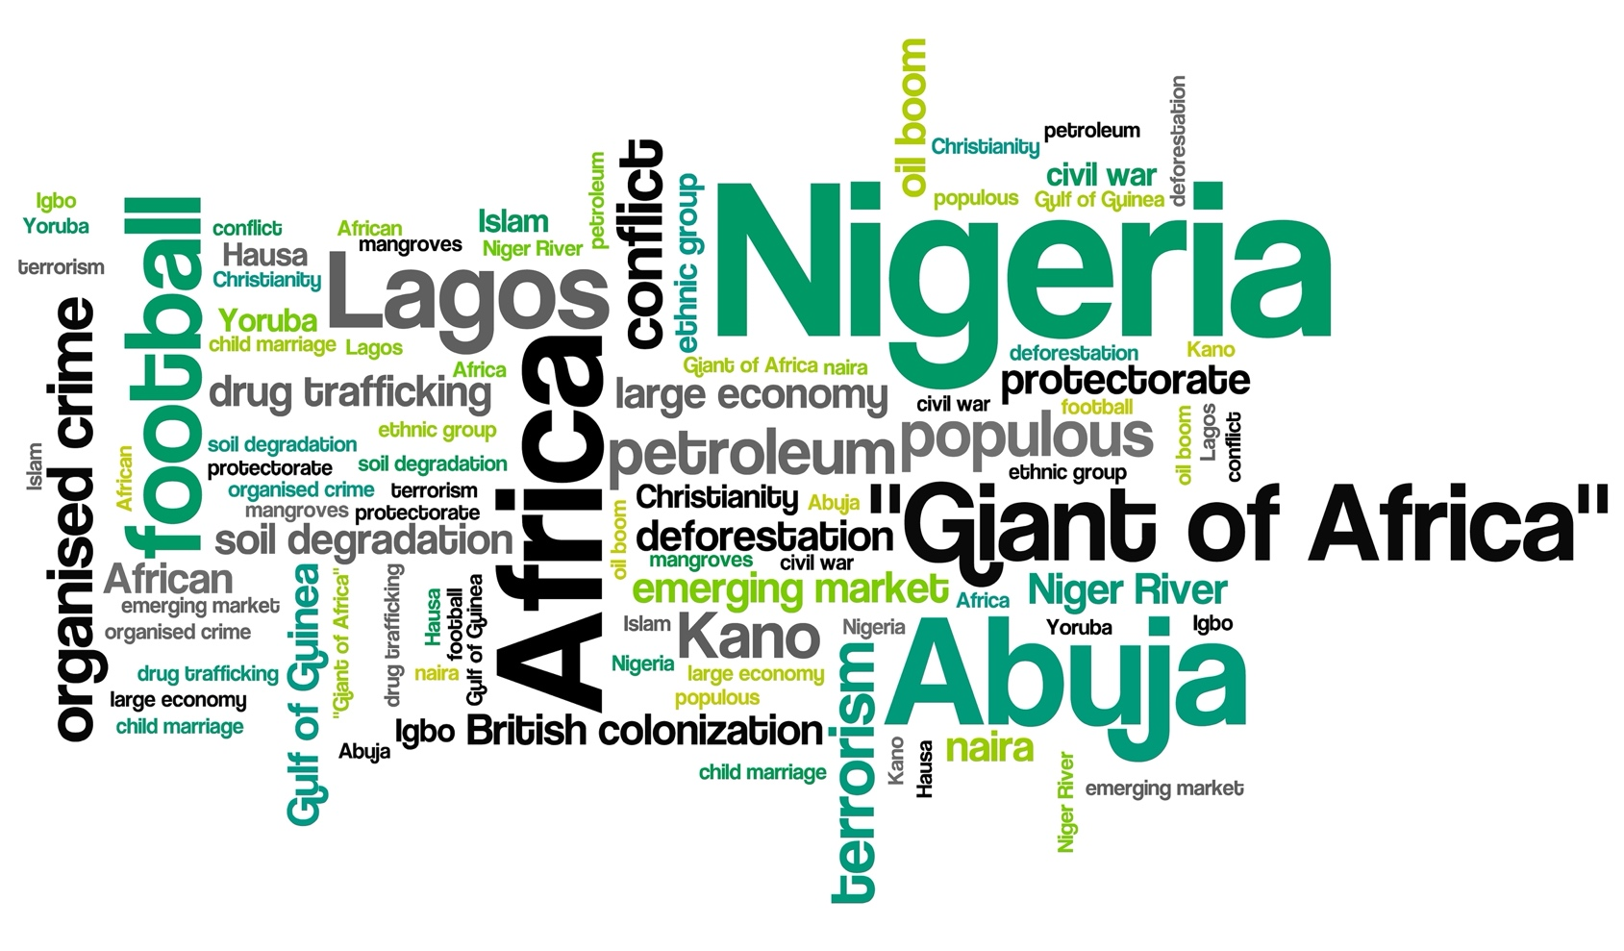

Changing Economic World - Economic development in Nigeria

Identify three challenges facing development in Nigeria in the future.

How are Nigeria’s political relationships changing?

Give three disadvantages of TNCs in Nigeria.

How can Fair trade reduce the development gap?

How are Nigeria’s trade relationships changing?

Give three issues associated with giving Nigeria aid.

Give three examples of the global importance of Nigeria?

Give three examples of the regional importance of Nigeria?

How is Nigeria’s industrial structure and economy balance changing?

Describe the location of Nigeria.

What have been the environmental impacts of urban growth in Nigeria?

Give two examples of how mining and oil extraction has had a negative impact on Nigeria.

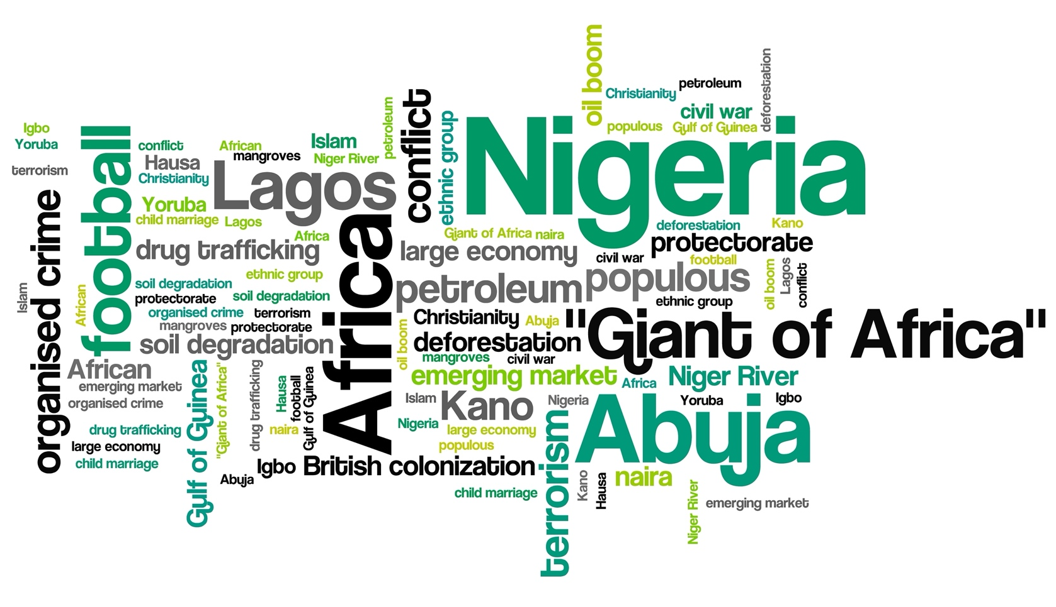

Changing Economic World - Economic development in Nigeria

* Rapid urban growth has led to urban sprawl, swallowing up the countryside
* The lack of sanitation and inadequate waste disposal has caused land and water pollution
* Emissions from cars and industry contribute to climate change
* profits leave the country and benefit shareholders, often in HICs
* paid wages tend to be lower than the home country of the TNC
* causing significant environmental damage, without taking responsibility for cleaning up
* being able to withdraw from a country if circumstances change
* powerful TNCs can exert pressure on governments
* raw materials are exported before being refined which reduces profits in LICs and NEEs

Fair trade involves paying farmers a fair price for their products and investing in local communities. Fair-trade also promotes fair wages for farmers and their workforce.

Despite still trading with the UK, Nigeria now conducts most of its trade with the some of the world’s largest economies including the EU, USA and India. Since becoming independent oil has become Nigeria’s main natural commodity export. However, the country still imports manufactured goods such as chemicals and machinery.

* Corruption in the government and individuals means aid is lost or not given to the right people
* There have been claims aid money has been used to supply the Navy
* Donors of aid may have political influence over who does and does not benefit. They may use donations to promote themselves.
* Nigeria’s most significant development challenge is overcoming the socio-economic inequality within the country. With over 50% of the population living in poverty, specific challenges need to be met.
* tackling government corruption to ensure wealth reaches everyone
* addressing environmental issues that have resulted from rapid economic development, such as soil erosion, water pollution, desertification and oil spills
* oil revenues should be maximised with profits invested in developing other areas of the economy
* conflicts between ethnic and religious groups need to be tackled sensitively
* basic sanitation provision for all needs to be a priority
* further investment in healthcare and education

Nigeria was originally part of the British Empire so more political and economic links were with the UK and other members of the Empire.

Since becoming independent in 1960 Nigeria has maintained strong links with the UK but also developed links with countries in Africa. Asia and the USA.

Nigeria now plays a leading political role in Africa.

Links with China are growing.

* Nigeria has the largest economy in Africa
* One of the fastest growing in the world
* Has a significant inequality gap between rich and poor
* Nigeria’s economy has transformed from agriculture to manufacturing and services
* Mechanisation and rural-urban migration has reduced employment in agriculture
* Countries such as the USA, China and South Africa have invested heavily in Nigeria
* Considerable growth in the service sector e.g. IT
* Oil and gas are important to the economy
* Fastest growing sector is manufacturing
* According to the World Bank Nigeria had the 31st largest GDP in 2018.
* It is the world’s 21st largest economy and has experienced recent rapid growth.
* It has the 7th largest population in the world.
* Nigeria is the 13th largest producer of oil
* Lagos, the capital city of Nigeria, is a thriving ‘world city’, with a strong financial and economic base.
* Nigeria has the second-largest film industry in the world, ahead of the United States and behind India. Nigerian cinema is known as “Nollywood”.
* Nigeria plays an important role in United Nations peacekeeping. According to the United Nations “Since the 1960s, Nigeria has been a major contributor of troops and police to United Nations peace operations, having served in dozens of missions.

Nigeria is located in West Africa, sharing a border with Benin, Niger, Chad and Cameroon. To the south, it borders the Gulf of Guinea, part of the Atlantic Ocean.

* Nigeria has the fastest growing economy in Africa and the highest GNP on the continent.
* Nigeria has the largest population on the continent and the third-largest manufacturing sector.
* The country also has the largest agricultural output and the highest number of cattle.
* Nigeria has a rich culture. Nigerian music is enjoyed throughout Africa. It is also a hub for literature boasting a range of popular writers. One of the main founders of the Organisation of African Unity (now the African Union or AU) was president of Nigeria in 1963.
* Oil spills have destroyed aquatic ecosystems
* Burning gases associated with oil extraction has caused considerable air pollution, leading to the release of greenhouse gases and causing respiratory problems for local people.
* Tin mining has caused soil erosion and has polluted water supplies.
* The oil company Royal Dutch Shell has caused devastating environmental pollution due to two massive oil spills at Bodo in Ogoniland, a small region of the Niger delta.