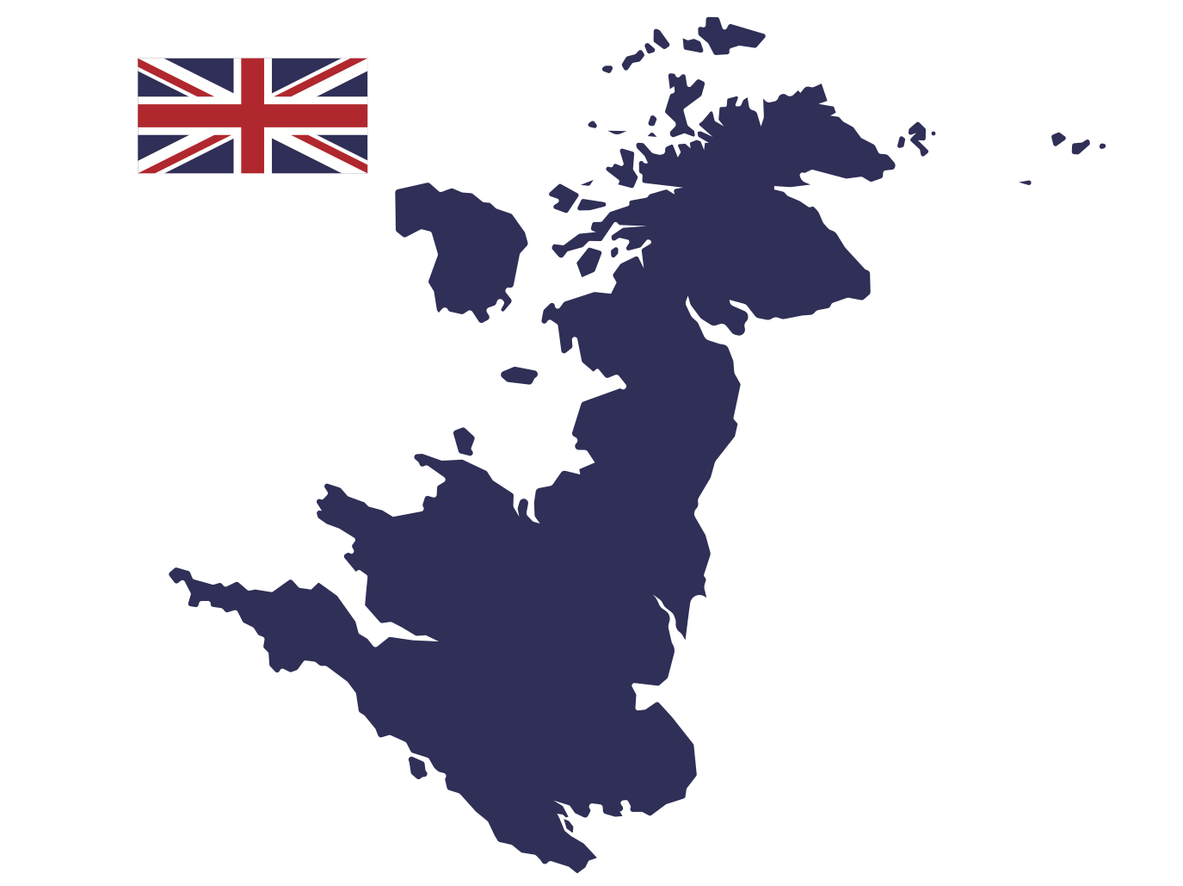

Changing Economic World - Changing UK economy

Identify two impacts of de-industrialisation on North-East England.

Give three characteristics of science parks.

Give an an example of how modern industrial development can be more environmentally sustainable.

What is the UK north-south divide?

Identify three impacts of industry on the physical environment.

How has the development of IT led to economic growth in the UK?

Give three impacts of globalisation on the UK.

What is de-industrialisation?

What did de-industrialisation in the UK involve?

Give a brief outline of how the UK’s employment structure changed during the 20th Century.

Identify 4 aspects of transport infrastructure being developed in the UK.

Give two examples of benefits of population growth in rural areas.



* Road network
* Rail network
* Ports
* Airports
* 1.3 million people are employed in IT
* Home-working and self-employment due to the internet
* The UK is viewed as one of the top IT countries in the world and receives overseas investment as a result.
* Technological developments have led to the growth of specialist manufacturing services along with service and research
* Information can be accessed anywhere using mobile devices
* The turnover of digital technology companies grew by 4.5% between 2016 and 2017, compared with 1.7% growth in UK GDP (this is 2.6 times faster than the overall economy)
* London-based technology businesses raised £9bn between 2015 and 2018
* Already, the UK represents a global centre of technology talent, accounting for 5 per cent of all high-growth technology workers employed globally.
* Coal mining led to the creation of spoil heaps, vast mounds of waste material removed during extraction.
* Burning coal, to generate electricity, led to considerable air pollution in cities across the UK.
* Toxic waste materials from heavy industry have polluted the land and water supplies.
* The north-south divide is a term used to describe the social, economic and cultural disparities between the London and the south-east of England and the rest of the UK.
* People living in the south-east typically have a longer life expectancy, higher income and better standard of living than those living in the north. House prices in the south-east are higher due to high demand. Rates of unemployment are higher in the north as regions continue to adjust to de-industrialisation.
* Science parks are typically located on the edge of university cities.
* They have good transport links and usually have attractive environments.
* Sometimes, science parks are located close to, or within, university grounds.
* Graduates are often employed to apply their knowledge and experience to innovative businesses.
* Businesses often have close links to local universities and tap into r&d
* Science parks employ around 75,000 people in the UK
* The closure of coal mines and shipyards
* De-industrialisation also led to a negative multiplier effect. Many smaller businesses that supplied and supported heavy industries closed, a knock-on effect affecting thousands of people.
* North East England has suffered huge job losses and a rise in unemployment as factories and industrial sites closed.
* Many of those employed in heavy industries struggled to find new jobs with the skills they have.

De-industrialisation in the UK has involved the decline of heavy industries such as coal mining, shipbuilding and steel manufacturing.

* a decrease in the number of people working in manufacturing as mechanisation (introduction of robots etc.) replaced jobs along with increased competition from abroad
* the service sector increased dramatically due to the introduction of public services, the growth of financial services and an increase in leisure time and disposable income
* since the 1980s the research and development sector has become increasingly important

De-industrialisation is the reduction of industrial activity or capacity in a region or economy, especially of heavy industry or manufacturing industry.

* Migration – Migrants fill jobs where there is a shortage of skilled workers in the UK, such as in healthcare and construction.
* Less manufacturing – Fewer goods are manufactured in the UK as they can be imported more cheaply in countries such as China where wages are lower.
* Inequality – The gap between the best-paid and lowest-paid jobs is increasing.
* Outsourcing – jobs are outsourced to other countries where wages are lower.
* Economic growth – in most cases, the UK economy increases by 1-2 per cent each year. This is mainly down to trade with other countries, helping the country to become wealthier over time.
* Foreign investment – foreign companies invest in the UK, bringing new ways of working and technology.
* Cheaper goods and services – Wages and production have become more competitive, leading to lower-priced products and services.

Changing Economic World - Changing UK economy

* Your answer will depend on the example you have studied. Below is an example for the Nissan Car Plant.
* The site has 10 wind turbines generating 6.6MW and 19,000 photo-voltaic panels (solar panels)
* Nissan is developing electric and hybrid cars.
* CO2 levels have been reduced by 22.4% since 2005.
* The Skills Academy for Sustainable Manufacturing and Innovation (SASMI) supports the industry’s future through specialist training.
* An increased population leads to a higher demand for goods and services. This helps ensure the future of rural shops, schools and businesses.
* It provides balance to rural-urban migration, particularly as young people move away in search for better opportunities.
* New people are more likely to invest in new, local businesses.
* New developments in rural areas provide jobs.