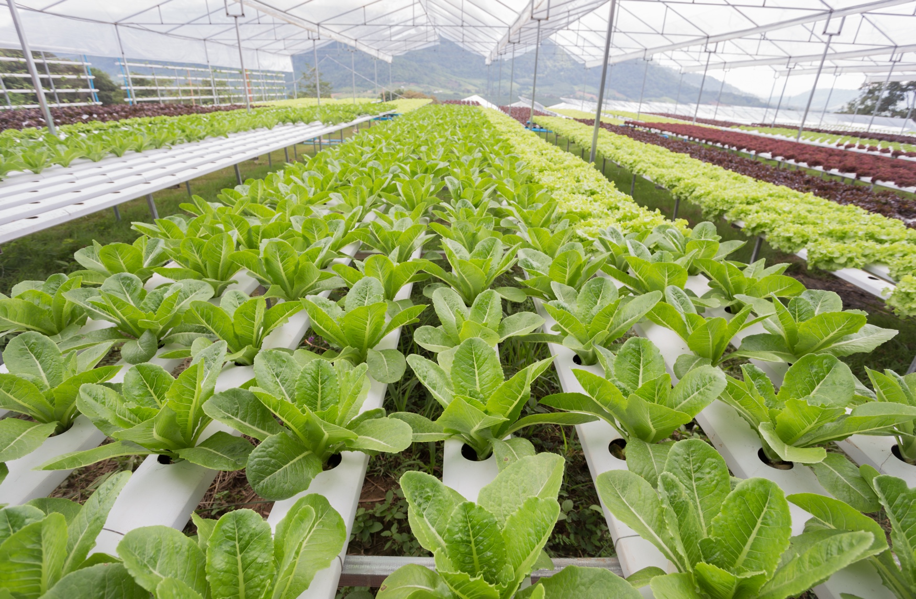

What is the difference between hydroponics and aeroponics?

Give the main features of the new green revolution.

Give two advantages and disadvantages of a large-scale agricultural development you have studied.

Identify 3 strategies for increasing food supply.

How have economic development and population growth caused an increase in food consumption?

Give three strategies for reducing food waste.

Identify the factors that affect food supply.

What is a sustainable food supply? Give three examples of sustainable food supplies.

Resource Management - Food

What are urban farming initiatives and what are their benefits?

What are the impacts of food insecurity?

Give the main features of a local scheme in an LIC/NEE to increase sustainable food supplies.

Define:

Food security -

Food insecurity -

Undernutrition -

Malnourishment -



Irrigation, aeroponics, hydroponics, biotechnology, new green revolution, appropriate technology.

Your answer will depend on your case study. Below is an example for Almeria, Spain.

**Advantages:** drip irrigation reduces water consumption in this dry area. Jobs created in greenhouses, packing and transport. New companies attracted to the area - multiplier effect. Fresh fruit and veg is available all year.

**Disadvantages:** low paid immigrant labour working in poor conditions. Social conflict between locals and migrants. Habitats and ecosystems affects by greenhouses. Natural water sources under stress. Pesticides are polluting water courses.

The new green revolution involves a more sustainable and environmentally approach to farming. It promotes crop rotation to support nutrient cycling, mixed arable and livestock farming in less fertile areas, water harvesting, soil conservation and the use of new seeds.

* As people become richer they have more money to buy a wider range and greater amount of food.
* As country becomes richer people consume more meat. More cereal is consumed by livestock.
* Demand for convenience and process foods increases with economic development.
* Population growth leads to more people needing food. This leads to increased pressure on production and supply.

The impacts of food insecurity include:

* Famine and undernourishment
* Rising prices
* Soil erosion
* Social unrest

Your answer will depend on your case study. Below is an example for Jamalpur, Bangladesh.

A rice-fish culture has been introduced. This involves introducing small fish to paddy fields. This helps aerate the water and fertilise the soil. It also provides a source of protein for local farmers. Rice yields have improved, and so have diets.

Resource Management - Food

Strategies for reducing food waste include:

* Introducing refrigerated storage if it does not exist
* Improve the transport infrastructure
* Processing food to extend its shelf life
* Using common sense when observing ‘best before’ dates on food

Climate, technology, pests and diseases, water stress, conflict and poverty.

**Food security** - having available food that is nutritionally adequate and safe. People have the ability to acquire food in a socially acceptable way.

**Food insecurity** - having limited or uncertain amounts of nutritional food available. People do not have the ability to acquire food in a socially acceptable way.

**Undernutrition** - a lack of a balanced diet e.g. some nutrients are lacking

**Malnourishment** - a lack of basic food

Hydroponics involves growing plants in a nutrient-rich water bath. However, aeroponics involves growing plants in the air, rather than soil. Plants are suspended in the air in a closed environment and feed on water and nutrients sprayed as a fine mist onto the roots and stems. As their roots are exposed to more oxygen the plants tend to grow faster.

Urban farming is a community initiative which involves converting derelict or waste land into vegetable gardens or productive farmland.

The benefits of urban farming initiatives include:

* Community cohesion
* Increased food security
* Healthier diets
* Improved natural environments
* Habitats for wildlife

A sustainable food supply involves producing food without causing any damage to the natural environment and brings benefits to the local community. Examples of sustainable strategies include organic farming, permaculture, urban farming initiatives, sustainable fishing and sustainable livestock.