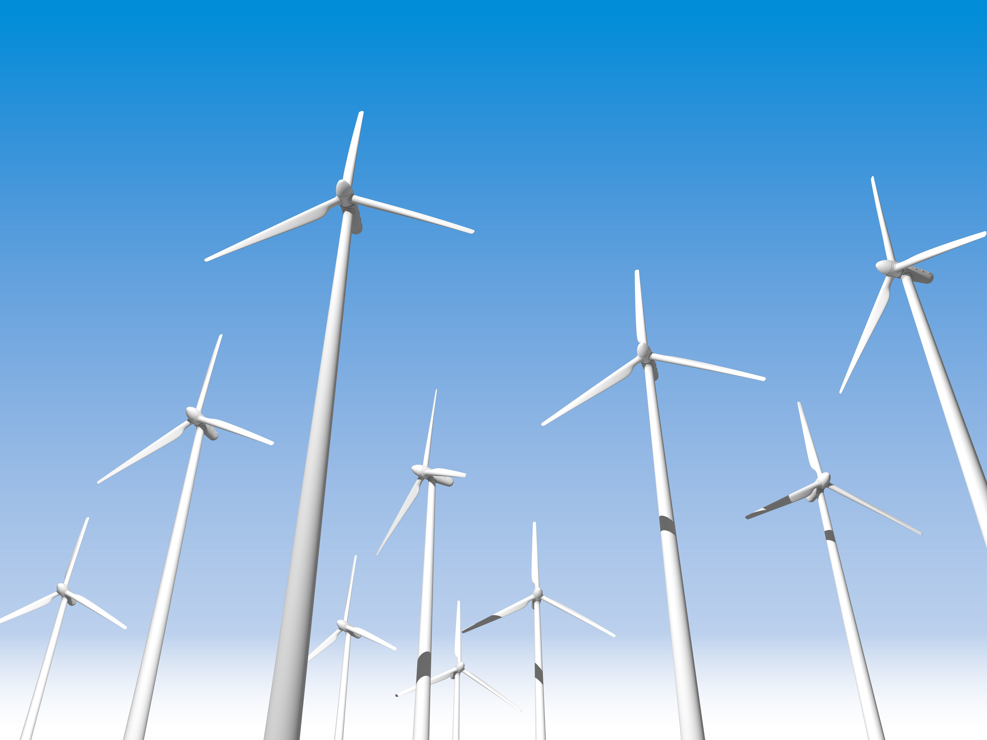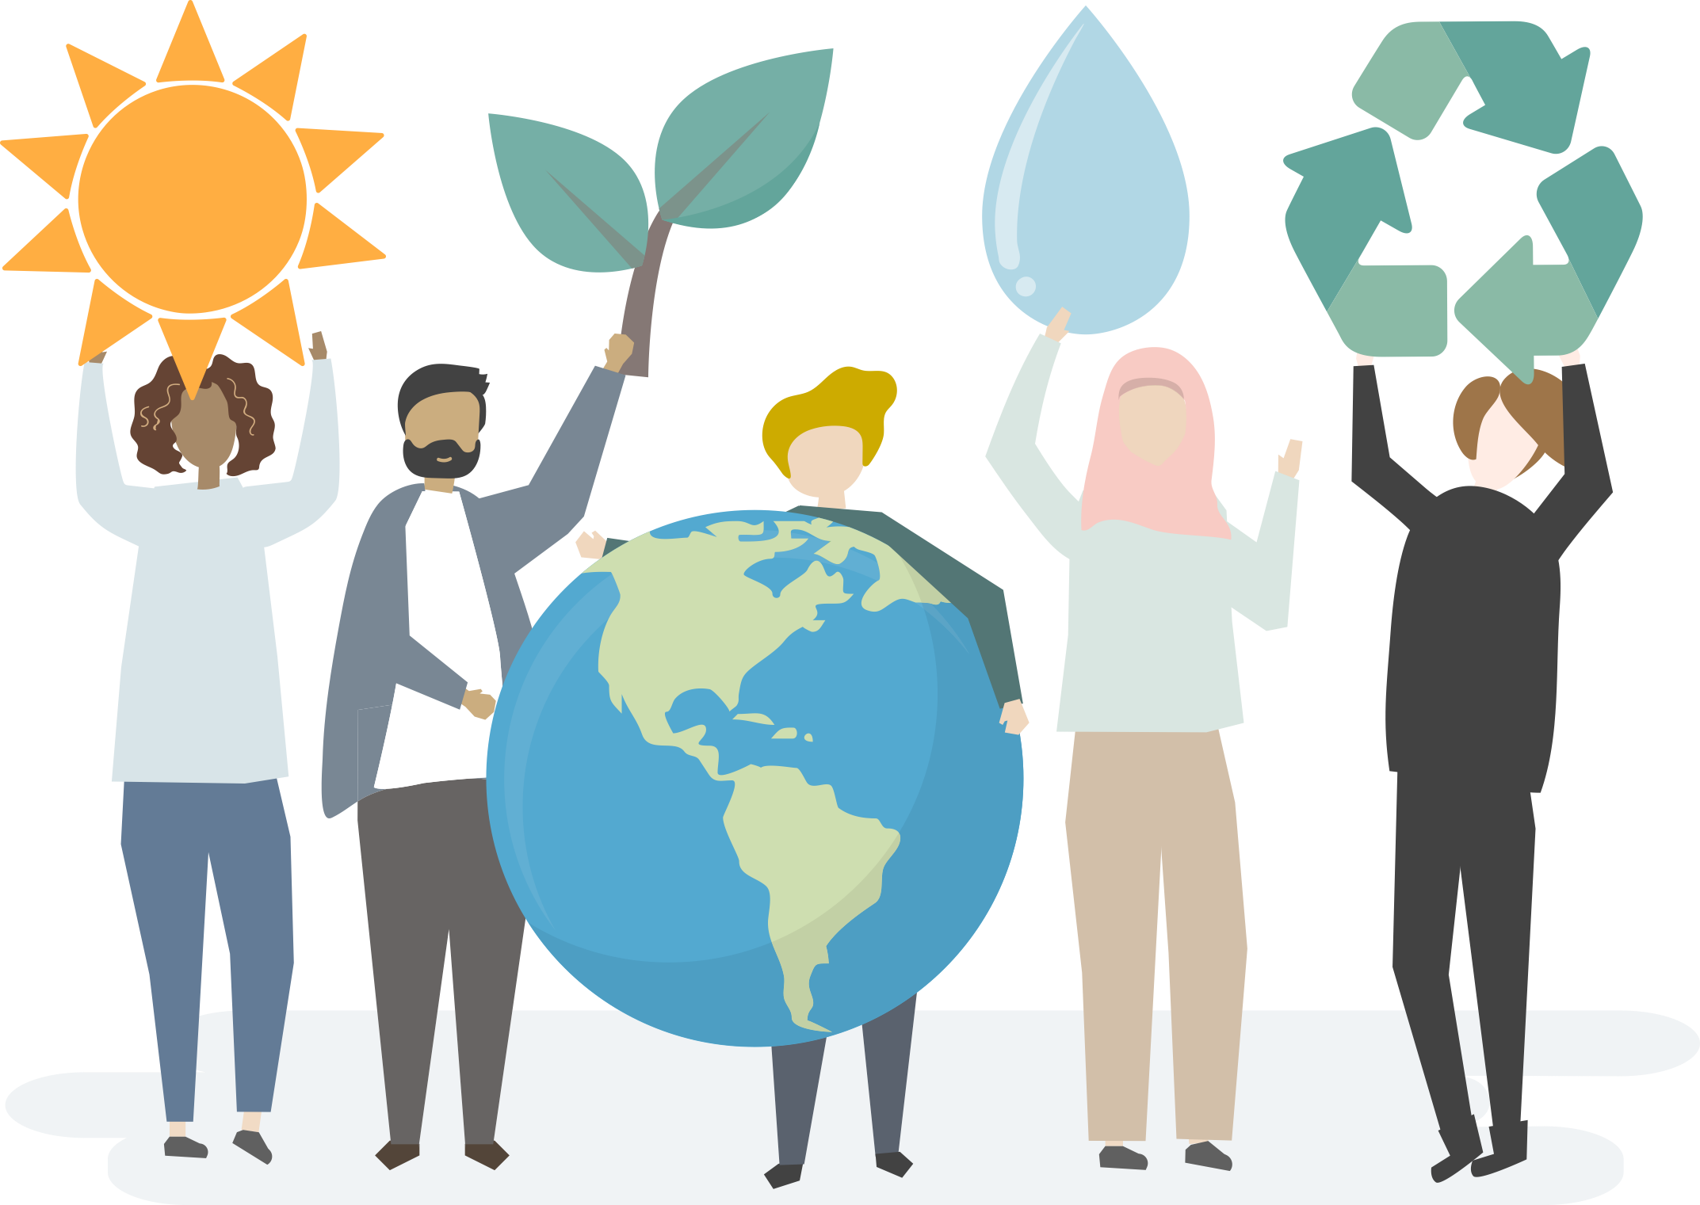

How is demand for food in the UK changing?

Describe the global inequalities in food.

Explain how agribusiness increases food production.

What are fossil fuels? Give three examples.

What are the causes and effects of water pollution in the UK?

How and why has the UK’s energy mix changed?

What is a resource?

What are the key resources needed for economic and social well-being?

How are food, water and energy significant for our well-being?

Give two environmental and economic issues associated with renewable energy.

Why is there a need to transfer water to maintain supplies in the UK?

Resource Management

Describe the global inequalities in the distribution of water.



There is a shift from fossil fuels and nuclear to renewable energy sources. Nuclear energy has fallen slightly. The use of fossil fuels has decreased due to their environmental impact and declining supplies within the UK. There has been an increase in the use of renewables because of their environmental benefits and it helps the UK meet its targets to reduce carbon emissions.

Agribusiness increases food production because farming takes place on a greater scale. The size of farms increases as hedgerows are removed when farms are combined. The greater use of mechanisation and chemicals also increases crop yields.

Large areas of Europe, Asia and North and South America produce a food surplus.

In a large proportion of countries in sub-Saharan Africa there is a food deficit. This is also the case in some Asian countries such as India, Pakistan, Bangladesh and Afghanistan.

A natural fuel such as coal or gas, formed in the geological past from the remains of living organisms.

Food, water and energy.

A resource is something which human society attaches value to due to its usefulness.

Food - calories are fuel for our bodies and are needed to work and enjoy ourselves.

Water - water is needed to drink to survive. We also need water to wash, dispose of wastes, grow and processes food and in industrial manufacturing.

Energy - we need energy to keep ourselves warm, construct houses, transport, process food and power machinery.

There is growing demand for high-value food exports such as Madagascan vanilla and specialist honey.

There is growing demand for all-year seasonal food such as strawberry, which can only be grown in summer in the UK.

There is a growing demand for organic produce as it is better for the environment and healthier.

* Africa, the Middle East and Australia is prone to water shortages and drought.
* Europe, South East Asia, northern South America and northern North America have a water surplus.

Economic:

* High set up costs
* Tourism declines as environments are not as attractive
* Low profitability is a concern

Environmental:

* They are considered unattractive
* Wind turbines can affect wildlife
* In upland areas large areas of land is flooded for reservoirs behind dams
* Biomass reduces biodiversity

Resource Management

**Causes:**

Chemicals and pesticides from agriculture

Oil from boats and ships

Untreated industrial waste

Oil and heavy metals from transport

Sewage pumped in to rivers and seas

**Effects:**

Pesticides kills wildlife

Eutrophication caused by fertilisers

Polluted drinking water

Fishermen and tourism suffer economic losses

The UK receives enough water to meet its demands. However, rainfall patterns do not match demand. Rainfall is greatest in the west of the country while the east receives less. The greatest demand for water comes from the south-east which is the driest area in the UK where there is a water deficit. Therefore, water needs to be transferred from the west to the south-east.