Mark Scheme

The Changing Economic World
Global variations in economic development and quality of life

- Award 2 marks if answer correct even if no working.
Allow one mark if evidence of attempting to work out correctly e.g. ranking of Figures on the table but answer subsequently wrong.
Dollar sign not necessary.
Median = 63 140
AO4 = 2 marks
- Award 2 marks if answer correct even if no working.
Allow one mark if evidence of attempting to work out correctly e.g. adding of Figures on the table but answer subsequently wrong.
Dollar sign not necessary.
1 mark if student calculates to a decimal.
Mean = 50013
AO4 = 2 marks
- Credit any reasonable suggestion.
Candidates should make reference to Figure 1 through using country name(s) and / or data provided, e.g.
Some of the countries are poor e.g. Afghanistan (1)
Afghanistan has a lower GNI than most other countries because it has a poorly developed economy (1)
European countries have the highest GNI scores because they have economies based around high value services (1)
The GNI scores around $2000 within the range are in NEEs as their economies have developed to create higher value. (1)
AO3 = 1 mark

- One mark for the correct alignment of each value in the plot.
Mexico does not have to be labelled.
AO4 = 1 mark

- Line should be straight, approximately in the centre of the scatter and inclined top left to bottom right.
AO4 = 1 mark

- Candidates should make reference to Figure 2 through using country name(s) and/or data provided. They should show that they can apply knowledge and understanding in analysing the relationship between economic development (GNI per capita) and birth rates. Expect recognition of the negative correlation between these variables, where higher-income countries generally have lower birth rates. Candidates should also connect this pattern to the Demographic Transition Model (DTM), recognising that as a country progresses economically, birth rates tend to decline due to social and economic factors.
Figure 2 shows a negative correlation between GNI and birth rate. (1)
Birth rates fall as countries develop, which can be linked to the stages of the DTM. (1)
As countries' GNI increases, people have better access to healthcare, contraception, and education, leading to lower birth rates. (1)
In wealthier nations, there is often greater gender equality and women prioritising careers, reducing birth rates. (1)
As infant mortality declines due to improved healthcare, families choose to have fewer children. (1)
Countries like the UK, Canada, and Germany in Figure 2 show low birth rates and high GNI, whereas Nigeria, Burkina Faso, and Afghanistan show the opposite trend. (1)
Max 1 mark if no reference to Figure 2, at least implicitly.
Reserve 3rd mark for the link between development and declining birth rates.
AO3 = 3 marks

- Candidates should clarify the factor and its resultant impact upon development. There is no requirement for an example though it may aid clarity and development.
Specification states this in the context of LIC/NEE but question does not, therefore allow valid positive points re HICs.
One mark for a basic statement, eg:
• countries used to be colonies (1)
• past wars left the country worse off (1).
Two marks for a developed idea, eg:
• many African countries were European colonies (1) this meant their resources were exploited for European gain and hindered their independent development (d) (1)
• past civil wars such as Mozambique 1977-1992 (1) left much of the infrastructure damaged and therefore hampered development (d) (1).
No credit for factors other than historic ones.
AO1 = 2 marks
- Candidates should clarify the factor and its resultant impact upon development. There is no requirement for an example, though it may aid clarity and development.
Specification states this in the context of LIC/NEE but question does not, therefore allow valid positive points re HICs.
One mark for a basic statement, eg:
• Countries have harsh climates (1).
• Some countries experience considerable natural hazards (1).
• Some countries are landlocked (1).
Two marks for a developed idea, eg:
• Countries with extreme climates, such as deserts, struggle to grow crops (1), leading to food shortages and making economic development difficult (d) (1).
• Frequent natural disasters such as earthquakes and floods (1) damage infrastructure, costing money to rebuild and preventing economic growth (d) (1).
• Landlocked countries, such as Chad, have no direct access to the sea (1), making trade more difficult and expensive, which slows economic development (d) (1).
No credit for factors other than physical ones.
AO1 = 2 marks
- Candidates should clarify the factor and its resultant impact upon development. There is no requirement for an example, though it may aid clarity and development.
Specification states this in the context of LIC/NEE but question does not, therefore allow valid positive points re HICs.
One mark for a basic statement, eg:
• The country has lots of debt (1).
• The country relies on low-value primary products (1).
Two marks for a developed idea, eg:
• Many LICs have high debt levels (1), meaning they have to spend money on repayments instead of investing in healthcare and education (d) (1).
• Countries that rely on exporting raw materials such as coffee or cotton (1) earn less than those producing high-value manufactured goods, slowing development (d) (1).
No credit for factors other than economic ones.
AO1 = 2 marks
- They should show an awareness of how economic measures, especially simplistic measures such as GNI, can be misleading eg Economic measures do not take any account of people’s quality of life (1) which is important in social terms (1) as development involves aspects other than simply economic (1) Economic measures tend to be per person (1) so do not allow for extremes of wealth and poverty (1) eg Saudi Arabia has vast oil wealth and high GNI which is not shared (1) Many economic measures are in US$ so do not allow for the relative spending power of different currencies (1) Economic measures have limited value in the poorest countries (1) because many people are subsistence farmers / work in the informal sector (1) so are economically active but will not feature in such measures (1).
Max 2 for 2 separate points
1x3, or (1+1)+1
No credit for general answers regarding the unreliability of single measures other than economic.
No credit for outlining the advantages of non-economic measures.
AO1 = 3 marks
- Candidates should show an awareness of how social measures, such as life expectancy, literacy rate, and access to healthcare, can be misleading when assessing development.
- Social measures often focus on just one aspect of development (1) and do not reflect overall economic or political conditions (1), meaning they give an incomplete picture (1).
- Some social measures, such as life expectancy, can be affected by factors other than development (1), for example, a country may have a low life expectancy due to conflict rather than poor healthcare (1).
- Data collection may be unreliable in some countries (1) due to poor governance, conflict, or lack of infrastructure, leading to inaccurate figures (1).
- Some measures, such as literacy rate, may not reflect differences between genders or social groups (1), meaning inequalities within a country are not fully shown (1).
- Social measures do not always consider quality (1), for example, high school enrolment rates do not guarantee a good standard of education (1).
Max 2 for 2 separate points.
1x3, or (1+1)+1
No credit for general answers regarding the unreliability of single measures other than social.
No credit for outlining the advantages of economic measures.
AO1 = 3 marks
- One mark for an initial overall comment or single relevant statement eg
• Birth rates may be affected by government policies. (1)
• Birth rates may not be accurate. (1)
• There may be great variation within a country. (1)
Second mark for developing the comment eg
• Birth rates may be affected by government policies (1) so more / less babies may be born if incentives / disincentives are offered. (d)(1)
• Birth rates may not be accurate (1) because there may not be a reliable system of recording births. (d)(1)
• There may be great variation within a country (1) with lower rates in the cities hiding high rates in rural areas / distorting the overall picture. (d)(1)
Credit any reasonable statement.
No credit for development measures other than birth rates.
AO1 – 2 marks
- One mark for an initial overall comment or single relevant statement, eg:
• Life expectancy may be affected by factors other than development. (1)
• Life expectancy data may not be reliable. (1)
• There may be significant variations within a country. (1)
Second mark for developing the comment, eg:
• Life expectancy may be affected by factors other than development (1), for example, a country with a high crime rate or conflict may have a lower life expectancy despite being economically developed. (d)(1)
• Life expectancy data may not be reliable (1) because some countries may lack accurate records or exclude rural populations. (d)(1)
• There may be significant variations within a country (1), with poorer regions or disadvantaged groups having much lower life expectancy than wealthier urban populations. (d)(1)
Credit any reasonable statement.
No credit for development measures other than life expectancy.
AO1 = 2 marks
- One mark for an initial overall comment or single relevant statement, eg:
• Infant mortality rates may be affected by factors other than development. (1)
• Data on infant mortality may not always be accurate. (1)
• There may be regional differences within a country. (1)
Second mark for developing the comment, eg:
• Infant mortality rates may be affected by factors other than development (1), such as disease outbreaks or conflict, which can increase deaths even in more developed countries. (d)(1)
• Data on infant mortality may not always be accurate (1) because some deaths, particularly in rural areas, may not be officially recorded. (d)(1)
• There may be regional differences within a country (1), with poorer or remote areas having much higher rates than urban centres, distorting the national average. (d)(1)
Credit any reasonable statement.
No credit for development measures other than infant mortality.
AO1 = 2 marks
- One mark for the correct answer.
D – Human Development Index (HDI)
No credit if two or more answers are circled.
AO1 – 1 mark
- IQR = 74,590
Award 2 marks if answer correct even if no working.
Allow one mark if evidence of attempting to work out correctly eg accurately calculating both upper and lower quartiles but answer subsequently wrong.
UQ = 76,590
LQ = 2000
AO4 – 2 marks
- 1+1
1 mark for accuracy in terms of death – ‘children/babies who die (under the age of 1)’/ number of children who die
1 mark for the accurate description of rate – ‘per 1000 (live) births per year’.
AO1 =2 marks

- 1+1
1 mark for accuracy in terms of birth – the number of babies born
1 mark for the accurate description of rate – ‘per 1000 of the population of an area per year’.
AO1 =2 marks

- 1+1
1 mark for accuracy in terms of death – the number of people who die
1 mark for the accurate description of rate – ‘per 1000 of the population of an area per year’.
AO1 =2 marks

- One mark for the correct answer.
A – The changes in a country’s population structure over time based on birth and death rates.
No credit if two or more answers are circled.
AO1 – 1 mark

- One mark for the correct answer.
B – Natural increase
No credit if two or more answers are circled.
AO1 – 1 mark

- 1+1+1
Or 1+1+1(d)
Or 1+1(d)+1(d)
Candidates should make reference to Figure 4 through reference to the birth and death rates and total population change shown in stage 3. They should show that they can apply knowledge and understanding by making the connection between stage 3 of the DTM and economic benefits.
Figure 4 shows birth rates falling, which means more money will be available in households (1) which can lead to increased spending in the country (1). Fewer babies being born can reduce the amount of money needed for maternity services and schools (1) which allows more to be spent on developing industry (1). As the total population increases there are more people to work in industry (1) so the country can increase its GNI (1).
Max 1 mark if no reference to Figure 4, at least implicitly.
No credit for reference to population change in isolation.
AO3 = 3 marks

- 1+1+1
Or 1+1+1(d)
Or 1+1(d)+1(d)
Candidates should make reference to Figure 4 through an implicit or explicit mention of the low birth and death rates and the declining total population seen in Stage 5. They should demonstrate an understanding of the economic challenges that arise due to these demographic changes.
Indicative Content:
Figure 4 shows birth rates falling below death rates, leading to an ageing population (1), which increases the dependency ratio and puts pressure on healthcare and pensions (1).
A shrinking working-age population means fewer taxpayers (1), leading to lower government revenue and potential increases in taxes to support the elderly (1).
Labour shortages may occur as fewer young people enter the workforce (1), making it harder for businesses to grow and leading to economic stagnation (1).
With fewer young people, demand for certain goods and services (e.g., schools and childcare) may decline (1), leading to job losses in these sectors (1).
Restrictions:
Max 1 mark if no reference to Figure 4, at least implicitly.
No credit for references to population change in isolation without linking to economic challenges.
AO3 = 3 marks

- One mark for the correct answer.
D – South America has no low income countries.
No credit if two or more answers are circled.
AO1 – 1 mark

- 23%
No credit given if decimal places given
AO4 – 1 mark

- 1+1+1
Or 1+1+1(d)
Or 1+1(d)+1(d)
People move from poorer countries to richer ones for better paid jobs / as economic migrants (1) and for a higher quality of life. (1) The wealth difference need not be large, it is the development gap which causes people to move (1) for example the estimated 900 000 Polish migrants in the UK. (1) Many people flee conflict in LICs and move to safer HICs (1) for example more than one million migrants to Europe from sub Saharan Africa 2010-2017. (1) Migrants may also be encouraged to move to other countries as a source of cheap labour (1) illustrated by the number of poorly paid Indian Sub-continent workers in gulf states such as Qatar / Mexicans moving to the USA. (1)
AO1 – 3 marks

- 1+1+1
Or 1+1+1(d)
Or 1+1(d)+1(d)
Uneven development means that wealth is not distributed equally between or within countries, leading to economic disparities.
Wealth is concentrated in more developed countries (HICs), while many LICs struggle with poverty (1), meaning people in LICs have lower incomes and limited access to economic opportunities (1).
Uneven development results in lower wages and fewer job opportunities in LICs (1), whereas in HICs, high-skilled industries create well-paid jobs, increasing wealth gaps globally (1).
Many LICs rely on exporting raw materials, which generate less income (1), whereas HICs produce high-value manufactured goods, increasing their wealth (1).
Wealth disparities exist within countries too, as urban areas tend to develop faster than rural areas (1), leading to greater economic inequality (1).
No credit for references to health disparities instead of wealth.
AO1 = 3 marks

- 1+1+1
Or 1+1+1(d)
Or 1+1(d)+1(d)
Uneven development leads to significant differences in healthcare access, life expectancy, and disease prevalence between countries and within societies.
LICs have less investment in healthcare (1), leading to higher rates of preventable diseases such as malaria or cholera (1).
HICs have better healthcare systems with trained professionals and advanced technology (1), leading to higher life expectancy and lower infant mortality rates (1).
People in LICs may suffer from malnutrition due to food insecurity (1), making them more vulnerable to disease and limiting economic productivity (1).
In wealthier countries, governments can afford free or subsidised healthcare (1), whereas in LICs, people may struggle to afford basic medical treatment (1).
No credit for references to wealth disparities instead of health.
AO1 = 3 marks
- 1 mark for correct completion of bar.
Shading is not necessary.
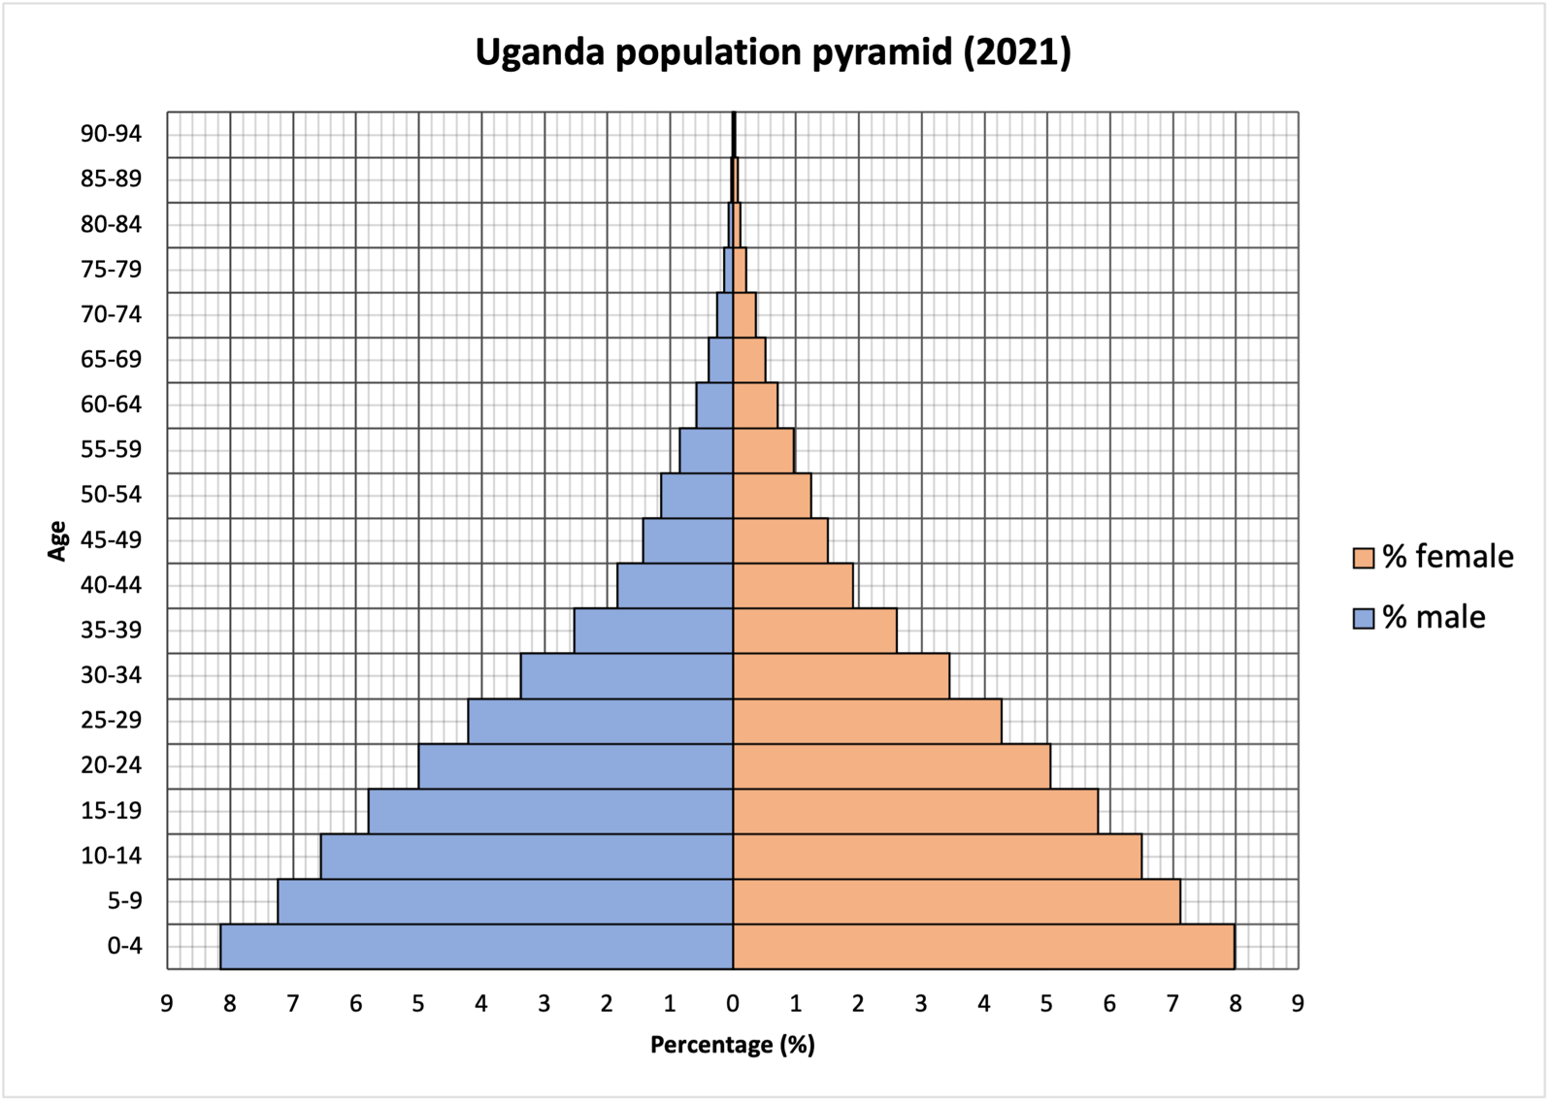

- One mark for the correct answer.
B – 10%
No credit if two or more answers are circled.
AO4 = 1 mark
- 1+1+1
Or 1+1+1(d)
Or 1+1(d)+1(d)
Uganda has a wide base due to high birth rates, often linked to limited family planning and cultural norms favouring large families (1).
The top of the pyramid is narrow, reflecting a lower life expectancy caused by factors such as inadequate healthcare and higher disease prevalence (1).
Overall, the pyramid’s shape indicates a youthful population, with many young dependents and fewer older people, typical of a lower-income country (1).
AO1 = 3 marks

- One mark for each correctly completed bar, width can be ignored. Shading not required.

