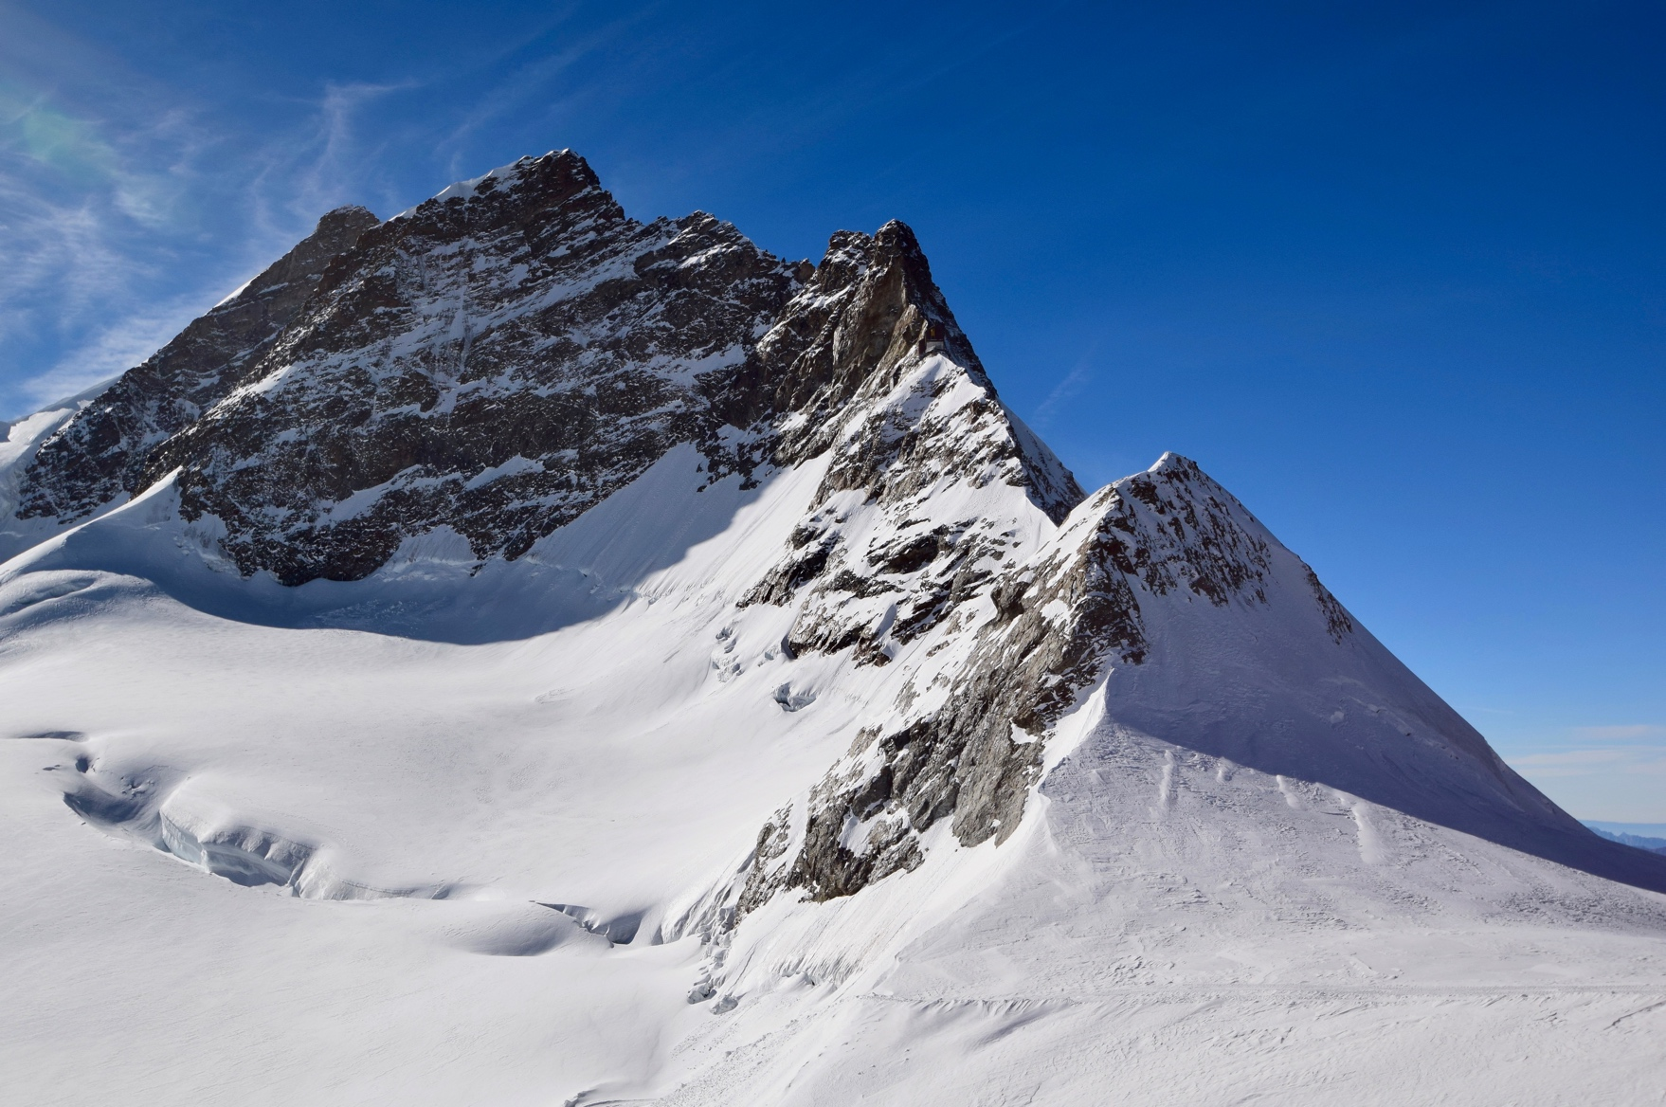

Give three ways development and conservation can be balanced in glacial upland areas.

Explain the formation of a corrie.

Identify 4 landforms resulting from ice transportation and deposition.

Identify 3 landforms of glacial erosion.

Give three ways a glacier transports material.

Identify the two types of glacial erosion. Describe each

Explain how glaciers move.

Give three economic activities that occur in glaciated upland areas.

Describe the process of freeze-thaw weathering.

Glacial environments

Give two examples of conflicts that can occur between groups in upland glaciated environments.

Give two landscape features of freeze-thaw weathering.





* Set maximum visitor numbers
* The use of signs to identify areas that are out of bounds
* Seasonal closure which can involve closing visitor attractions in winter to allow the environment to recover
* Restrict activities such as the use of motorbikes and horse riding.

Corrie, arête, u-shaped valley, hanging valley, truncated spur and pyramidal peak.

Moraine (lateral, medial, terminal and ground moraine), drumlins and erratics.

The snout of the glacier bulldozes material which is moved forward by the sheer weight of the ice.

Material is also carried on the surface of the glacier as the result of weathering on the mountainsides above the glacier.

Material is also carried inside the glacier, on the base where plucking has occurred. It is also found inside where rocks fall down crevasses.

Glacial environments

Water enters cracks in the rock face. It freezes and expands. This causes the crack to become larger by 10%. Subsequent freezing and thawing enlarges the crack causing rock to break away. Large blocks of rock can be shattered by repeated freeze-thaw weathering.

* Walkers objecting to military training.
* Constructing dams and reservoirs can cause locals to be relocated.
* Tourists and walkers may object to wind turbines ruining the landscape
* Conservations are against hunting
* Environmentalists object to conifer plantations as they destroy habitats
* Local people object to commercial logging as it can cause localised flooding



**Plucking** - as a glacier moves over the Earth’s surface, meltwater freezes around loose rock, pulling them away.

**Abrasion** - rocks frozen to the base of a glacier act like sandpaper scratching and scraping the bedrock below.

Snow accumulates in shady-north-facing hollows in upland areas. It becomes compressed forming ice. Gravity causes it to flow over the lip. The glacier slides over the bedrock on a film of meltwater, a process called basal flow. The glacier can also move when it is too cold for basal flow by a processes called internal deformation, when the ice moves like plastic.

Corries are formed when snow accumulates in a hollow in the side of a mountain. If the snow does not melt during the summer further snowfall leads to the accumulation of snow, which, over time, becomes compressed forming ice. Freeze-thaw weathering supports the formation of ice by removing air. The accumulated ice begins to flow from the hollow. As this happens plucking removes rocks and debris which freezes to the base of the glacier. As the glacier moves this material abrades the hollow causing it to get wider, deeper and steeper. On the back wall of the corries, above the ice, freeze-thaw weathering causes the top of the ice to be covered in rock debris. Over time, the back wall retreats backwards, cutting deep into the side of the mountain.

Scree slopes and block-fields

Farming (extensive agriculture), forestry, tourism and quarrying.