Mark Scheme

Natural Hazards

- One mark for an appropriate definition.
The probability or chance that a natural hazard may take place (1)
AO1 – 1 mark

- One mark for an appropriate definition.
A natural event that threatens people or has the potential to cause damage, destruction and death (1)
No credit for quoting examples of natural hazards.
AO1 – 1 mark

Tectonic Hazards

- One mark for an appropriate definition.
A natural hazard caused by movement of tectonic plates (including volcanoes and earthquakes). (1)
AO1 – 1 mark

- One mark for an appropriate definition.
A sudden or violent movement within the Earth’s crust followed by a series of shocks. (1)
AO1 – 1 mark

- One mark for correct answer
This question requires application of knowledge to the source.
Constructive plate margin
No credit for explanations of plate movement or direction of plate movement.
AO3 – 1 mark
- Destructive, convergent
No credit for explanations of plate movement or direction of plate movement.
AO3 – 1 mark
- Conservative (passive) plate margin
No credit for explanations of plate movement or direction of plate movement.
AO3 – 1 mark

- Destructive plate margin
No credit for explanations of plate movement or direction of plate movement.
AO3 – 1 mark

- Volcano/volcanic eruption, tsunami, earthquake
No credit for non-tectonic hazard
AO3 –1 mark
- One mark for correct answer
This question requires application of knowledge to the source.
Constructive plate margin
No credit for explanations of plate movement or direction of plate movement.
AO3 – 1 mark

- One mark for each correct characteristic.

e.g. The distribution of volcanoes over our planet’s surface is not random (1). Most of the Earth’s volcanoes are huddled on the edges of the continents, lining island chains, or forming long mountain ranges underneath the ocean (1). Most are found around the Pacific Ring of Fire (1). Location related to plate margins should also be credited.

A01 - 2 marks

- Destructive, convergent
No credit for explanations of plate movement or direction of plate movement.
AO3 – 1 mark

- Earthquakes, Volcanoes or Tsunamis
No credit for explanations of plate movement or direction of plate movement.
AO2 – 2 marks

- Conservative, passive
No credit for explanations of plate movement or direction of plate movement.
AO3 – 1 mark

- Earthquakes
No credit for explanations of plate movement or direction of plate movement.
AO2 – 1 mark

- Constructive
No credit for explanations of plate movement or direction of plate movement.
AO3 – 1 mark

- Volcanoes, Earthquakes
No credit for explanations of plate movement or direction of plate movement.
AO2 – 1 mark

- 1 mark for making a point, second mark for development.
e.g. Japan is located close to a (destructive) plate margin whereas the UK is not (1) therefore, when friction is overcome as the plates move Japan experiences earthquakes (d) (1).
AO3 – 2 marks

- 28% (2 marks) Working and units not needed.
Allow 1 mark for evidence of correct working even if final answer is wrong.
Allow maximum 1 mark if figure expressed with 1–2 decimal places (27.9 or 27.97).
AO4 – 2 marks

- 225,891 (2 marks) Working and units not needed.
Allow 1 mark for evidence of correct working even if final answer is wrong.
Allow maximum 1 mark if figure expressed with 1 decimal places (225891.4).
AO4 – 2 marks

- 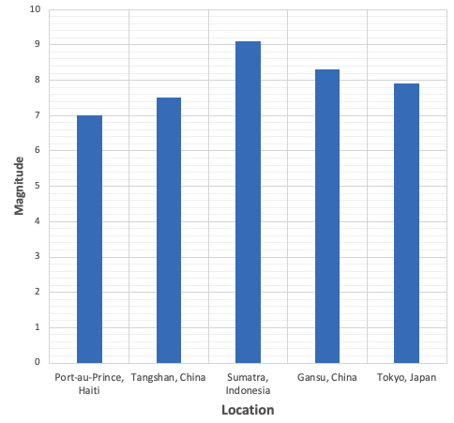
A04 – 1 mark

- One mark for features described, and 1 mark for developed point.
e.g. Earthquake drills can be practiced at least once a year (1) this will help people respond when an earthquake occurs e.g. seek shelter under a desk (d) (1).
AO1 – 2 marks
- One mark for a feature and two marks for a developed explanation.
Volcanoes at constructive plate margins have gentle slopes (1), whereas those on destructive plate margins have steep slopes (1), because of the differences in lava temperature and composition (1).
AO1 – 1 mark AO2 – 2 marks

- One mark for reason, and 1 mark for developed point.
e.g. Building quality and standards tend to be lower in LICs compared to HICs (1), therefore they are more likely to collapse leading to a higher death rate (1).

AO2 – 2 marks

- One mark for reason, and 1 mark for developed point.
e.g. Land close to volcanoes is often used for agriculture (1), this is because the land is fertile from deposits from previous eruptions so farmers commonly live close to such active zones. (1).

AO2 – 2 marks

- Prepare emergency aid and distribution (1). Practise earthquake/volcano drills. (1) Plan evacuation routes (1). Stockpile blankets, clean water and food (1). Educate people so they know what to do if an earthquake or volcano happens (1). Prepare hazard maps to show areas most at risk of damage (1).
2 separate ways are required.
AO1 – 2 marks
- Building and transport infrastructure design (e.g. foundations with shock absorbers) (1), sea walls in case of tsunamis (1). Evacuation instructed by authorities (1).
2 separate ways are required.
AO1 – 2 marks

- Changes in shape of the ground and volcano using tiltmeters and GPS (1), earthquakes near magma chamber using seismometers (1), ground surface and river temperatures using thermal heat sensors (1), radon sulphur gas using gas-trapping bottles (1), foreshocks using seismometers and GPS (1).
2 separate ways are required.
AO1 – 2 marks
- One mark for point, and 1 mark for development.
e.g. Because we know that earthquakes occur along plate margins we can identify potential places that they will occur (1), however, earthquakes occur when friction between two tectonic plates is overcome and this can occur at any time which makes predicting the timing of earthquakes very challenging (1).

Tropical Storms
- Eg High sea temperatures/sea temperatures above 26/27 degrees C (1)
They form over the oceans, where water provides moisture/gives energy (1)
Water vapour is evaporated from the ocean surface, which provides “fuel” for the storm (1) Because at the Equator there isn’t enough spin from the earth’s rotation (Coriolis effect). (1)
Heat makes air unstable/makes the air rise rapidly. (1)
Low wind shear (1)
2 separate reasons are required.
AO1 – 2 marks
- They may affect areas further from the Equator. (1)
They could affect parts of the sub tropics/the South Atlantic/NE USA. (1)
They could have a broader distribution/affect larger parts of the world. (1)
Credit alternative idea (As the science is uncertain) regions where tropical storms take place are not expected to change much as a result of climate change. (1)
AO1 – 1 mark
- Credit use of direction, starting point, distances, dates and named locations.
Eg Hurricane travelled north west towards Cuba initially (1) it then changed direction, travelling north north west towards Florida (1)
Its movement was in a northerly direction (1)
It passed over Cuba (1)
It reached landfall over Florida and moved towards South Carolina (1) Max 1 mark for list of countries/places
No credit for changes in intensity. AO4 - 2 marks
- The wind increased (1)
It increased from a category 3 to category 4 (1)
It increased to over 178 km/hour (1)
Wind speed increased rapidly (1)
AO4 - 1 mark
- 178-208 km/hour
No credit if units of measurement is not included.
AO4 - 1 mark
- E.g. There is no (clear) relationship/there is not a direct link (1) Some of the storms causing most deaths had lower max wind speeds / some storms causing more deaths had very high wind speeds (1) (Avoid double crediting). Credit qualified use of data from the table e.g. the 3 storms causing the highest number of deaths all had lower wind speeds than the 4 with the least deaths (1)/The Bhola cyclone had the lowest max wind speed yet recorded the greatest number of deaths. (1)

Credit data manipulation

No credit for explanations of the data.

No credit for just disagreeing with the statement

AO4 – 2 marks

- 47% (2 marks) Working and units not needed.

Allow 1 mark for evidence of correct working even if final answer is wrong.

Allow maximum 1 mark if figure expressed with 1–2 decimal places (46.98 or 46.9).

AO4 – 2 marks

- 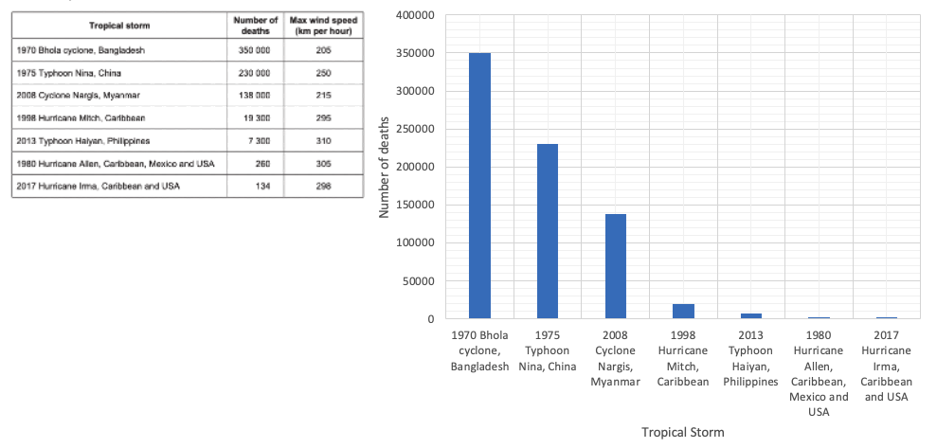
AO4 – 1 mark

- One mark for reason, and 1 mark for developed point.
The range in values is very high (1) therefore it is challenging to accurately read the data (1).
AO2 – 1 mark

- Hurricanes need a lot of heat to form, which is why they usually occur over tropical seas (at least 26°C). The warm ocean heats the air above it causing it to rise rapidly. Water evaporates quickly from the hot surface of the ocean, so the rising air contains great amounts of water vapour.
AO2 - 1 mark
- Hurricanes need a lot of heat to form, which is why they usually occur over tropical seas (at least 26°C). over land they are no longer receiving heat energy and moisture from the ocean, which is needed to drive the storm reducing wind speed.
AO2 - 1 mark

- Low latitudes
- Between 5°–30° north and south of the Equator
- Originate in oceans with temperatures above 27°C
- Ocean depth 60–70m
- Between summer and autumn
- Low wind shear
- Not along the Equator
Two conditions required for full marks.
AO2 - 2 marks

- They occur (in late summer/autumn) when sea temperatures are highest (over 26/27°C)/ water temperatures of at least 26/27°C are needed down to a depth of at least 50 m/they require high sea temperatures (1). Only occur when atmosphere is unstable (enough for convection and thunderstorms) (1).
Reference to higher temperatures on their own is insufficient-must mention sea or water temperatures
AO1 – 1 mark

- One mark for reason, and 1 mark for developed point.
e.g. A large number of people die by drowning (1) caused by storm surges create by strong winds and low air pressure. (1)
People are made homeless (1) due to strong winds damaging and destroying homes. (1)
AO2 – 2 marks

- One mark for reason, and 1 mark for developed point.
Windows, doors, and roofs reinforced (1) to strengthen buildings and withstand strong winds (1).
Houses constructed on stilts (1) so that the storm surge will pass beneath (1).

Storm shelters built (1) so that people can evacuate from exposed areas e.g. on the coast and will be safer (1).
AO2 – 2 marks

- Two answers required for full marks.
e.g.
• They may become more frequent.
• They may become more intense.
• The distribution of tropical storms may be increased.
AO1 – 2 marks
- Credit 2 different ideas or one developed statement
The cyclone has an eye at the centre (1)
The centre/circular eye has no cloud (1)
There is a mass(swirl) of clouds surrounding the eye
(1) The vortex around the eye consists of dense cloud (1)
Clouds have a circular pattern (1)
Clouds appear to be arranged in an anti-clockwise pattern (1)
Clouds become patchy towards the edge of the cyclone (1)
The main parts of the storm are the central eye (1) surrounded by a vortex/eye wall of clouds (d) 1 The centre or eye is cloudless (1) but dense clouds are arranged in a circular pattern around the eye (d) 1
No credit for size of storm using the scale
No credit for explanation of structure or for description of movement.
AO4 – 2 marks

Global Atmospheric Circulation

- One mark for reason, and 1 mark for developed point.
e.g. Temperatures at the equator are high because incoming solar radiation is more intense as the sun’s energy is more concentrated (1). Due to high temperatures at the equator, the air rises into the atmosphere creating low pressure (1).
AO4 – 2 marks

- One mark for reason, and 1 mark for developed point.
E.g. Winds blow from high pressure areas to low pressure areas (1). E.g. The trade winds blow from 30 degrees N and S towards the Equator (d) (1).
Winds converge in areas of low pressure (1) e.g. the Polar easterlies meet the westerlies at 60 degrees S (d) (1).
Sinking air causes high pressure (1) which leads to winds moving away/diverging (d) (1).
AO4 – 2 marks
- One mark for reason, and 1 mark for developed point.
Air is heated by the sun / air rises rapidly along the Equator (1). The air cools and condensation occurs (d) (1). This leads to heavy showers and frequent (convectional) thunderstorms. (d) (1)
AO3 – 2 marks
- One mark for reason, and 1 mark for developed point.
e.g. When air rising at the equator reaches the top of the atmosphere it needs somewhere to go. Some of the air travels north and some south of the equator. The air cools and then sinks at around 30° north and south of the equator (1). As the air is sinking this creates high pressure. (1)
AO4 – 2 marks
- One mark for reason, and 1 mark for developed point.
e.g. Moisture in the air sinking around 30° north and south of the equator fell at the equator (1), therefore it is dry when it sinks, leading to few clouds and rainfall (d) (1).
AO3 – 2 marks
- One mark for reason, and 1 mark for developed point.
e.g. Global atmospheric circulation carries heat and moisture to other places (1) for example the UK gets warmth from south-westerly winds from warm sub-tropical locations (d). (1).
Global atmospheric circulation forms winds (1), which heat up the north Atlantic and make it warmer than it would be without the warm current (d) (1).
AO3 – 2 marks

Climate Change

- One mark for an appropriate definition.
A long-term change in the earth's climate, especially a change due to an increase in the average atmospheric temperature (1).
No credit for rearranging the wording of the question or for quoting examples of climate change. No credit for “global warming”.
AO1 – 1 mark
- One natural cause should be identified.
The specification includes:
- ((Burning) fossil fuels/ (1)
- (Large-scale) agriculture (1)
- (Increasing) Deforestation (1).

Accept other valid human causes.
Reject natural causes such as variations in solar output.
AO1 - 1 mark
- One human cause should be identified.
The specification includes:
- (Changes to the ) earth’s orbit/ (1)
- (Changes in) volcanic activity (1)
- (Variations in) solar output/ sunspot activity (1).

Accept other valid natural causes such as movement of tectonic plates, shifts in ocean currents/El Nino effects.
Reject human causes such as the enhanced greenhouse effect.
AO1 - 1 mark

- One mark for reason, and 1 mark for developed point.
Volcanic eruptions release volcanic ash into the atmosphere (1) this can block out sunlight, reducing temperatures (d) (1)
Sulphur dioxide emitted during a volcanic eruption mixes with water vapour and forms sulfuric acid (1), this reflects the Sun’s radiation, reducing temperatures (d) (1).
AO2 – 2 marks

- One mark for reason, and 1 mark for developed point.
Sunspots increase from a minimum to maximum every 11 years (1) low sunspot activity coincides with colder temperatures and high sunspot activity coincides with warm temperatures (d) (1).
AO2 – 2 marks
- One mark for reason, and 1 mark for developed point.
The Earth’s orbit is an ellipse (1), this means every 100,000 years the distance between the sun and Earth changes , when the Earth is closer temperatures are warmer, when it is further away it is colder (d) (1).
AO2 – 2 marks
- One mark for reason, and 1 mark for developed point.
Burning fossil fuels releases carbon dioxide (1) this means that less reflected radiation from the Earth’s surface can escape, increasing temperatures (d) (1).
AO2 – 2 marks
- One mark for reason, and 1 mark for developed point.
Cattle release methane during digestion (1), this contributes to greenhouse gases in the atmosphere which results in less reflected radiation from the Earth’s surface can escape, increasing temperatures (d) (1).
AO2 – 2 marks
- One mark for reason, and 1 mark for developed point.
Trees are a global store of carbon dioxide (1), cutting down trees means less CO₂ is absorbed increasing greenhouse gases in the atmosphere which in turn leads to higher temperatures as less reflected radiation from the Earth’s surface can escape, increasing temperatures (d) (1).
AO2 – 2 marks

- Shrinking ice sheets/glaciers/reduced Arctic or sea ice/less snowfall (1)
Sea level rise (1)
Extreme weather events/more droughts/ more tropical storms (1)
Ocean acidification (1)
Desertification (1)
Increased concentration of greenhouse gases/higher CO2 concentration
Accept longer term evidence such as ice cores, tree rings, ocean sediments, rocks and fossils, pollen analysis.
AO1 - 2 marks

- One mark for reason, and 1 mark for developed point.
e.g. Renewable energy sources such as HEP, solar, wind and tides do not emit large amounts of CO2 (1) as the result of this they offer a solution to reducing the volume of greenhouses gases in the atmosphere so more reflected solar radiation form the Earth’s surface can escape (d) (1).
Other areas students might consider: Some are renewable and last into the future. Nuclear is another source with little or no release of CO2.
AO2 – 2 marks

- One mark for reason, and 1 mark for developed point.
e.g. Planting trees helps remove CO₂ from the atmosphere through photosynthesis (1) reducing the volume of greenhouses gases in the atmosphere so more reflected solar radiation from the Earth’s surface can escape reducing climate change (d) (1).
AO2 – 2 marks

- One mark for reason, and 1 mark for developed point.
e.g. Carbon capture takes carbon dioxide from emission sources and safely stores it underground (1) reducing the volume of greenhouses gases in the atmosphere so more reflected solar radiation from the Earth’s surface can escape reducing climate change (d) (1).
AO2 – 2 marks

- One mark for reason, and 1 mark for developed point.
e.g. International agreements encourage countries to take responsibility for reducing CO₂ emissions (1), reducing the volume of greenhouses gases in the atmosphere so more reflected solar radiation from the Earth’s surface can escape reducing climate change (d) (1).
AO2 – 2 marks
- One mark for basic difference, and 1 mark for developed point.
e.g. Climate change mitigation involves preventing the causes of climate change such using renewable energy instead of fossil fuels, whereas climate change adaptation means responding to climate change by reducing its adverse effects, such as constructing sea defences to reduce coastal flooding and erosion.
AO2 – 2 marks

- One mark for reason, and 1 mark for developed point.
Changes in agricultural systems are required to deal with changing temperature and rainfall patterns (1) for example production may need to move to a new location to suit climates (d) (1) irrigation may be necessary due to drier conditions (d) (1), changes to crops and varieties may be necessary (d) (1).
AO2 – 2 marks

- One mark for reason, and 1 mark for developed point.
e.g. Managing water supplies ensures populations can face the challenge of changing rainfall patterns (1) for example, water transfer schemes may become necessary to move water from areas of surplus to areas of deficit (d) (1).
AO2 – 2 marks

- One mark for reason, and 1 mark for developed point.
e.g. Reducing the risk of the effects of climate change involves taking steps to decrease its social, economic and environmental impacts (1) for example the Thames Barrier has been constructed to reduce the risk of flooding along the River Thames due to rising sea levels (d) (1).
AO2 – 2 marks

- One mark per correct answer. The specification lists:
- Alternative energy production
- Planting trees
- Carbon capture
- International agreements
AO1 – 2 marks

- One mark per correct answer. The specification lists:
- Changes in agricultural systems
- Managing water supplies
- Reducing risk
AO1 – 2 marks

- 711% (2 marks) Working and units not needed.

Allow 1 mark for evidence of correct working even if final answer is wrong.

Allow maximum 1 mark if figure expressed with 1–2 decimal places (711.11 or 711.1).

AO4 – 2 marks

UK Weather Hazards

- One mark for an appropriate definition.
Weather that is unexpected (1), unusual (1), severe (1), unseasonal (1), significantly different from the normal pattern (1)/not normal to a particular area (1)
Weather (event) that can cause a threat to life(1)
Weather (event) that can cause damage (to property)(1)
No credit for rearranging the wording of the question or for quoting examples of extreme weather. No credit for “different weather”.
AO1 – 1 mark

- One mark per correct answer. The specification lists:
- Storm events
- Flooding
- Droughts
- Heatwaves
- Extremes of cold weather
AO1 – 1 mark

- One mark for reason, and 1 mark for developed point.
e.g. The frequency of extreme weather in the UK is increasing (1), since the 1980s, UK temperatures have increased by around 1°C and winter rainfall has increased (d) (1).
AO2 – 2 marks
- One mark for an appropriate prediction e.g.
- precipitation is expected to become more seasonal.
- Some rivers are expected to flood more frequently in winter due to increased rainfall.
- Air temperature is expected to increase, causing more drought.
- Storms are expected to become more intense.
AO1 – 1 mark

